**Project Name :** AmAccessBiz PC5  
**Test Script ID :** AABAI_JomPay_Limit_02  
**Platform :** Mac OS X  
**App Version :**   
**Run Date :** 02/27/2024  
**Run Started :** 12:34:00  
**Run Ended :** 12:38:34  
**Execution Time :** 00hrs 04mins 34secs   
**Execution Status :** Passed  
  
  
**Test Step 1(PASS) :** [BBO] Input [Username]  
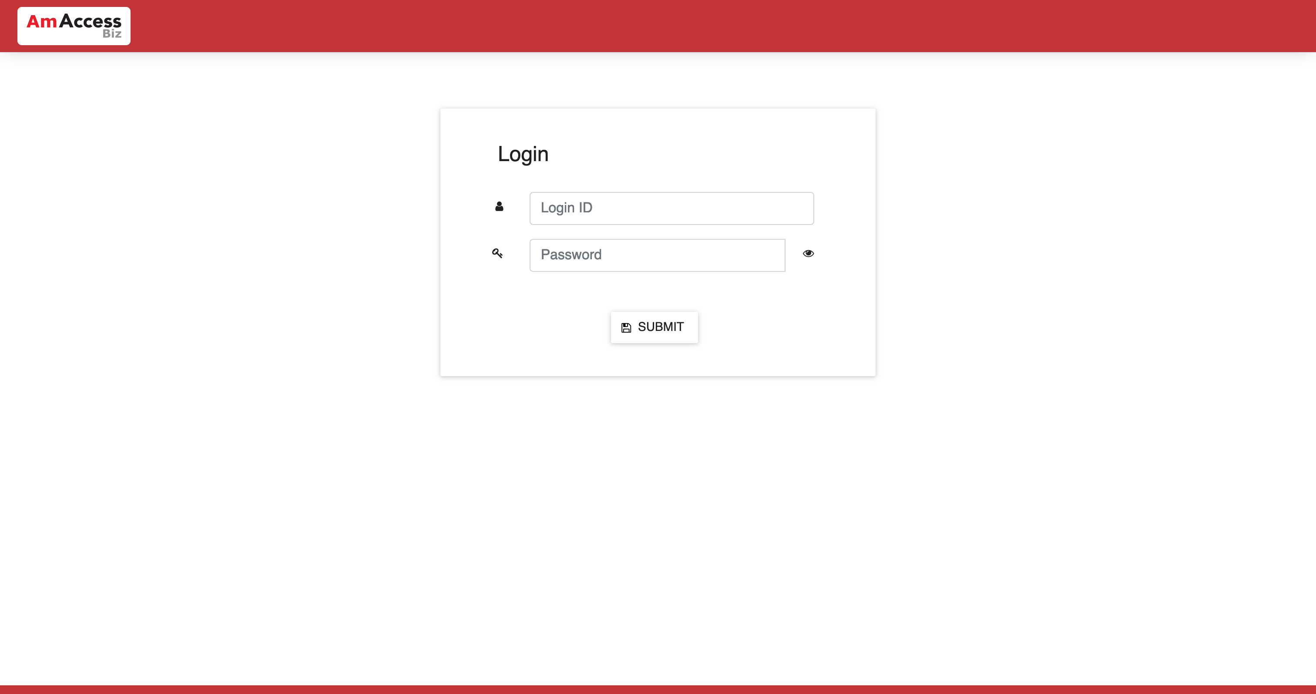  
  
**Test Step 2(PASS) :** [BBO] Input [Password]  
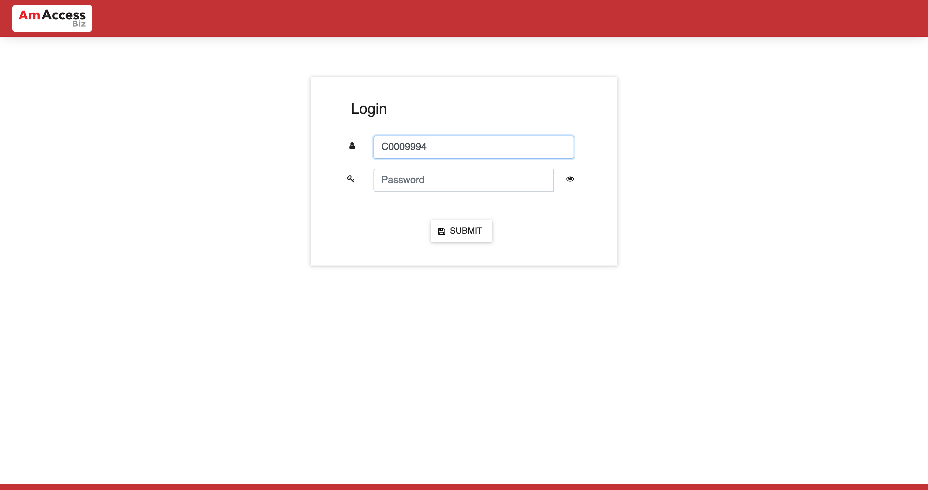  
  
**Test Step 3(PASS) :** [BBO] Click [Submit]  
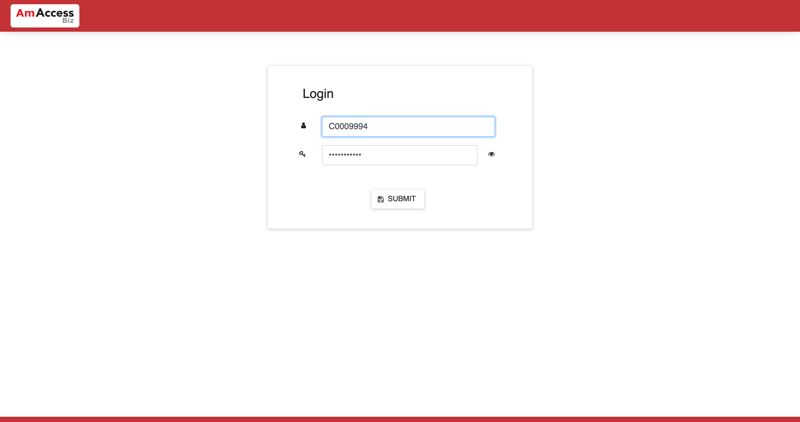  
  
**Test Step 4(PASS) :** [BBO] [Board] Click [Company Fullfilment]  
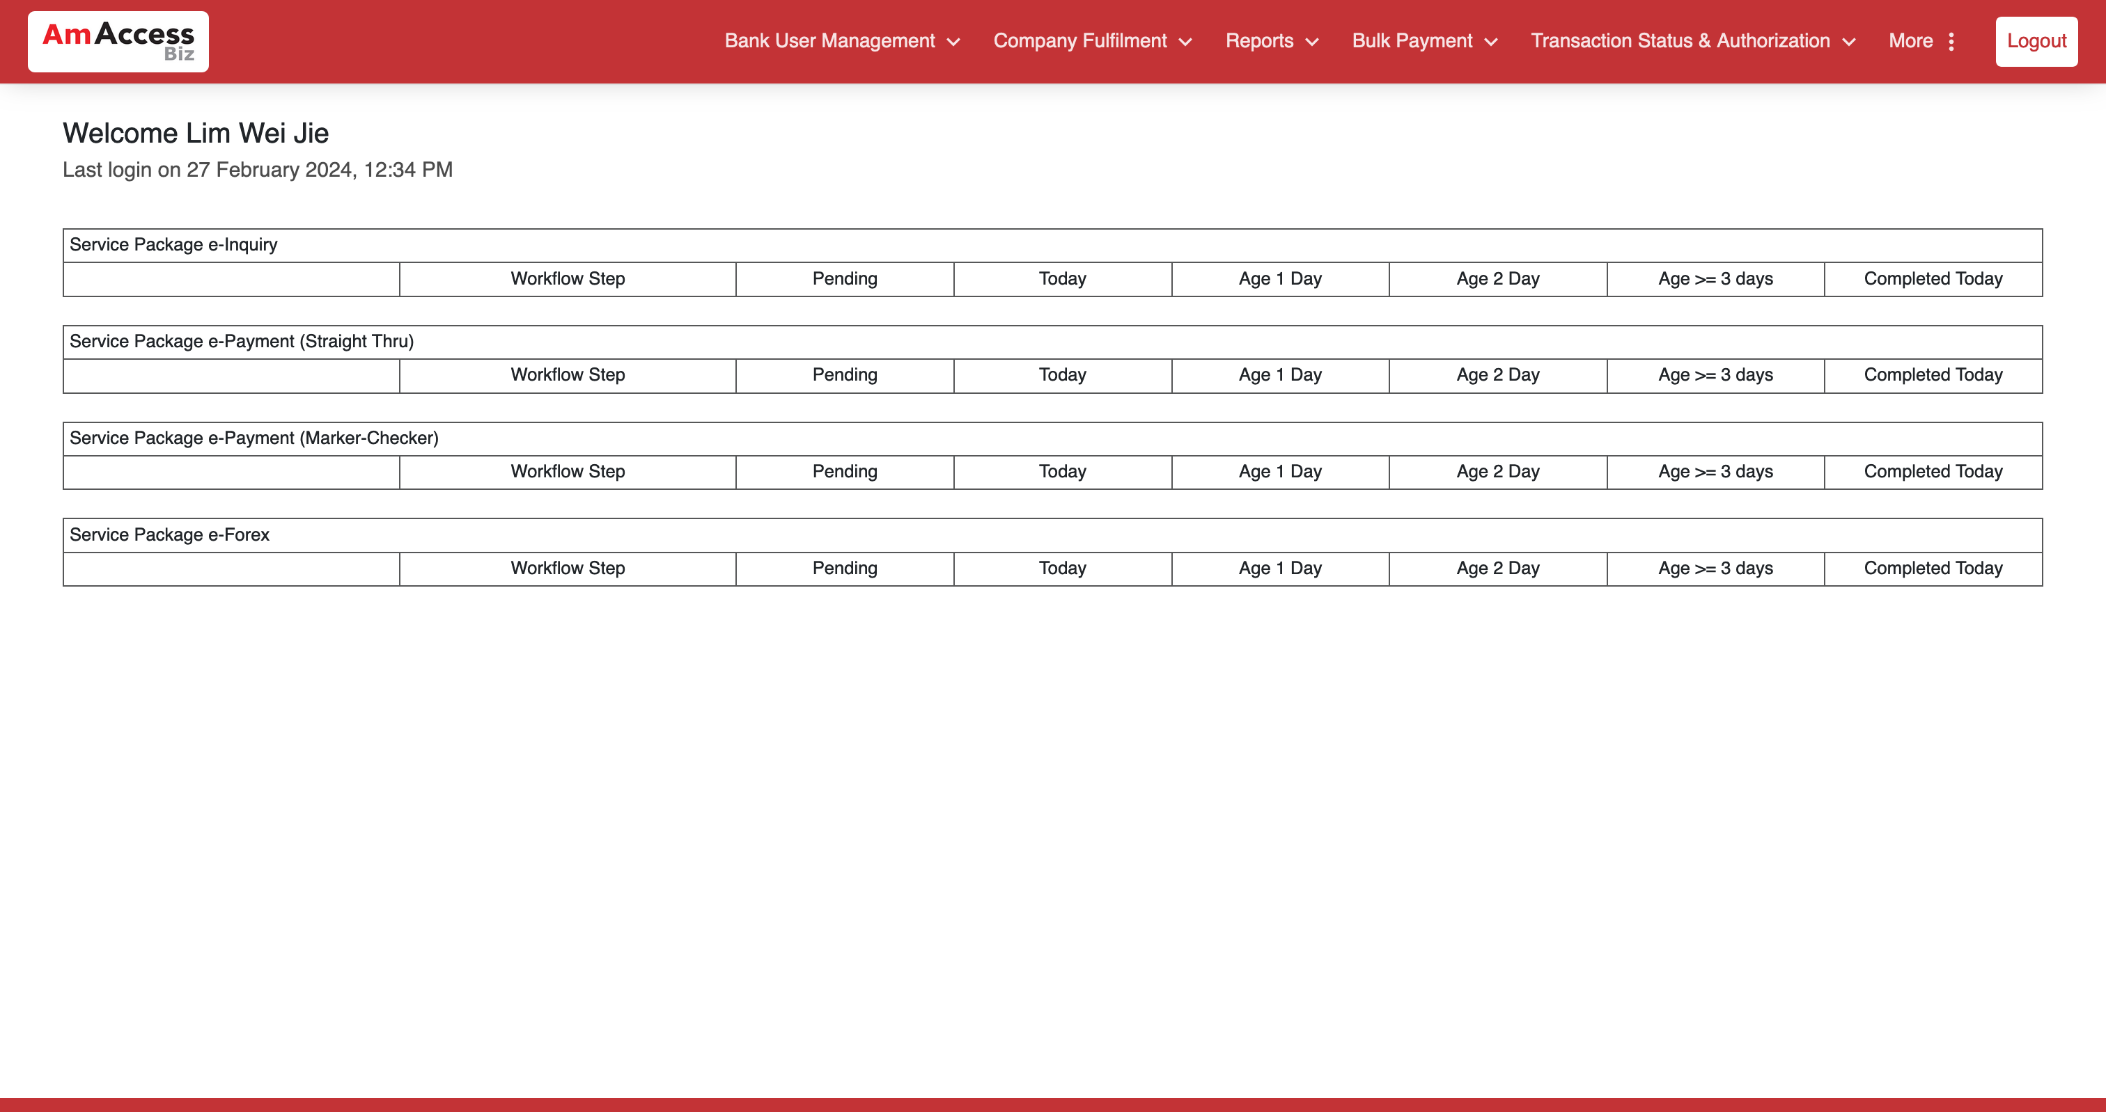  
  
**Test Step 5(PASS) :** [BBO] [Company Fullfilment] Click [Company Profile]   
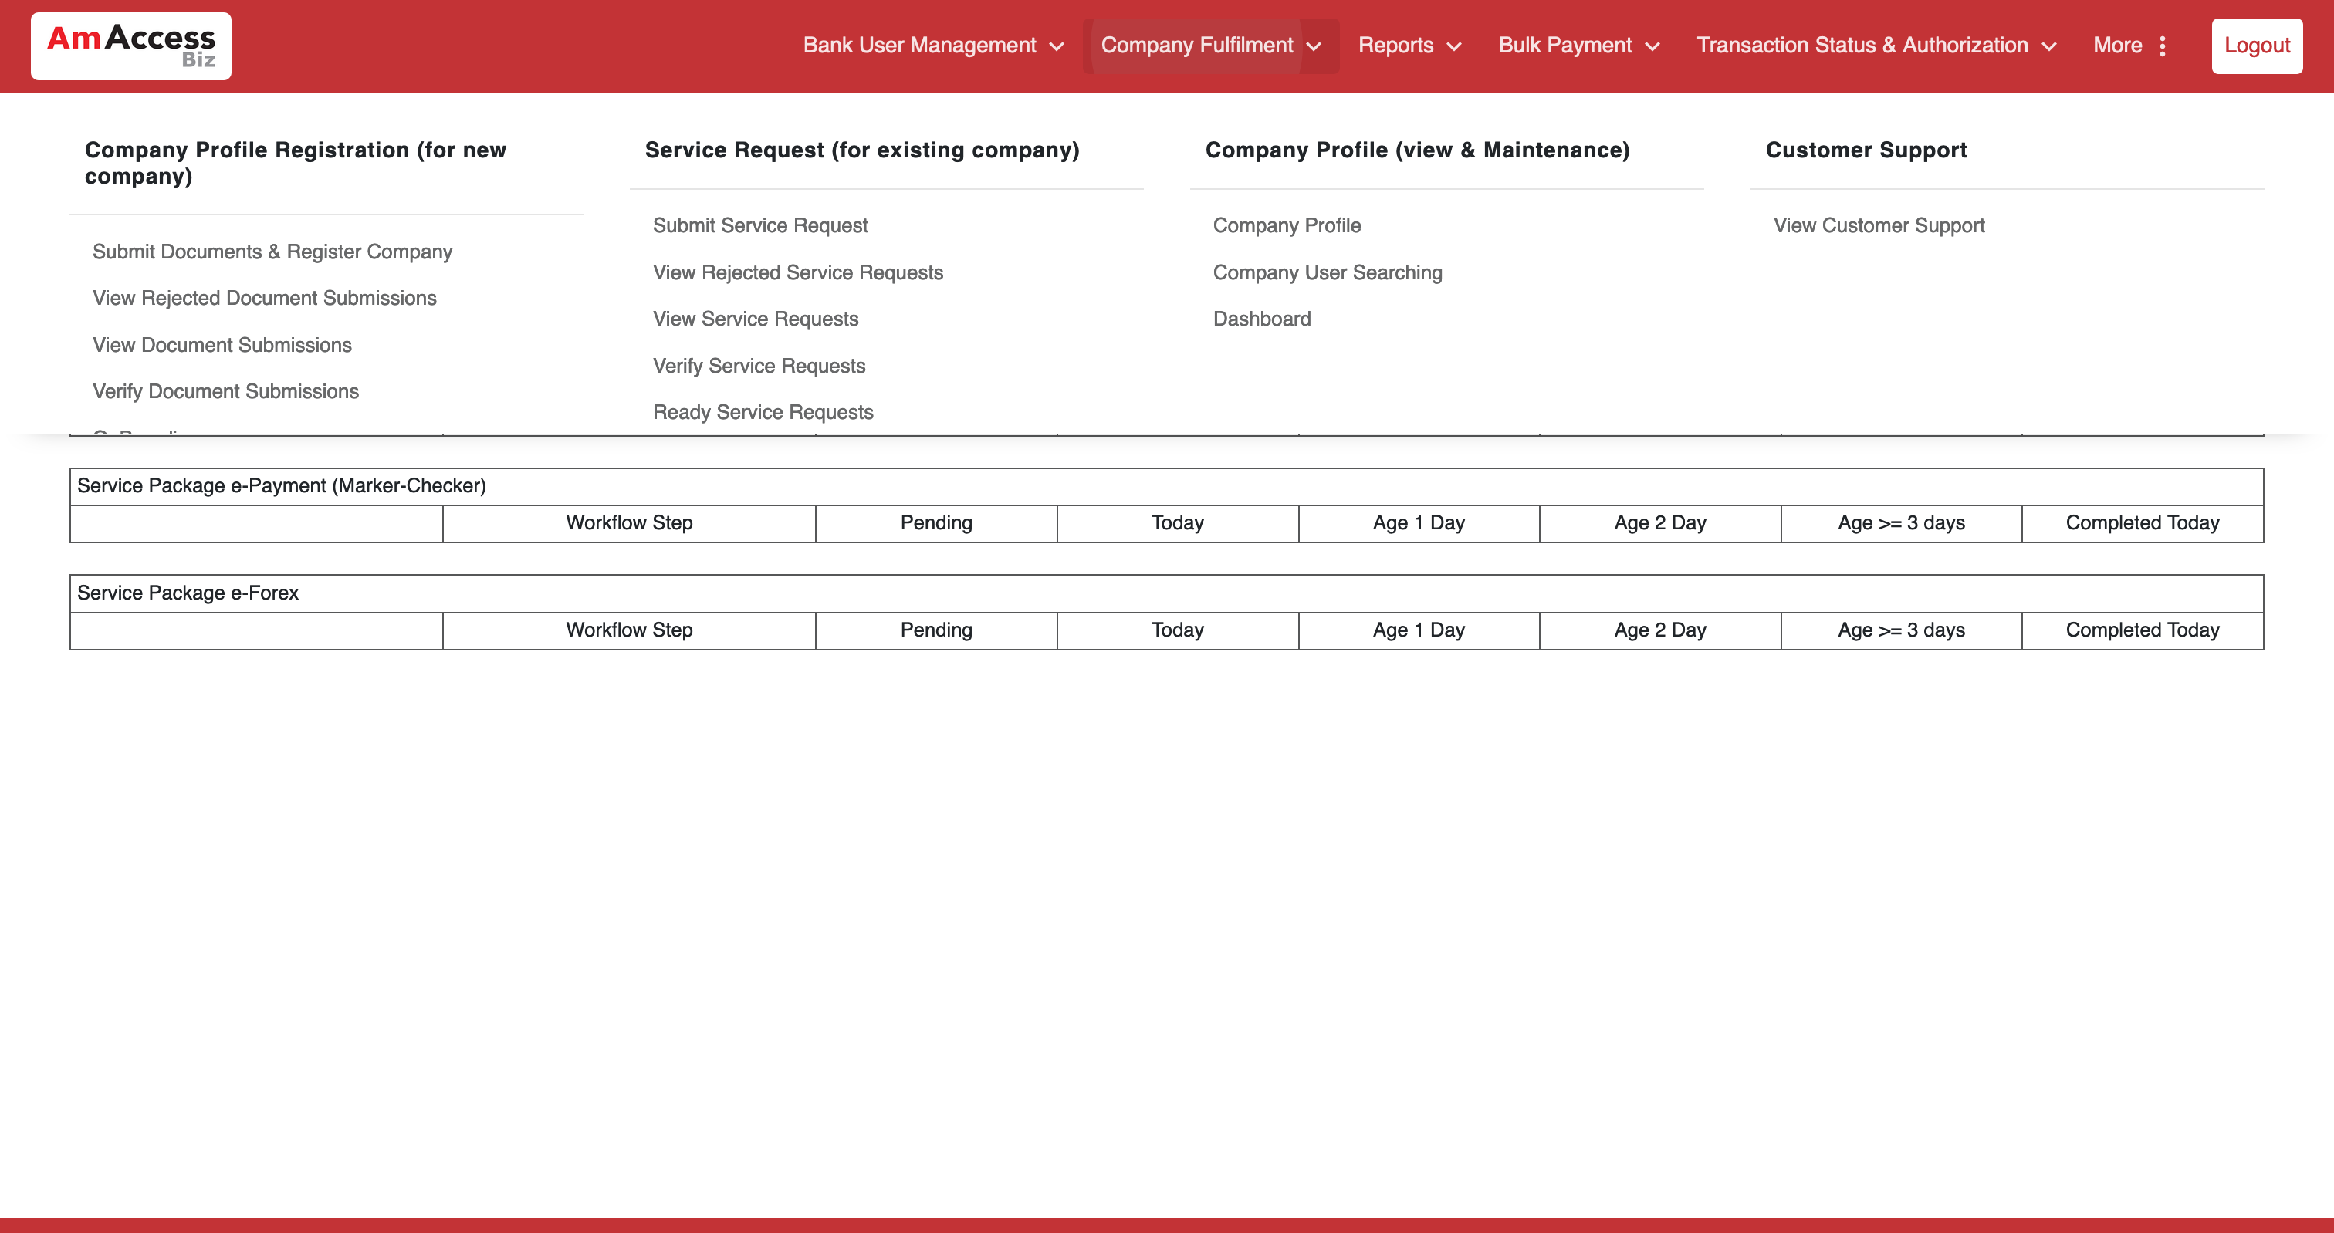  
  
**Test Step 6(PASS) :** [BBO] [Profile Maintenance] Input [CIF Number]  
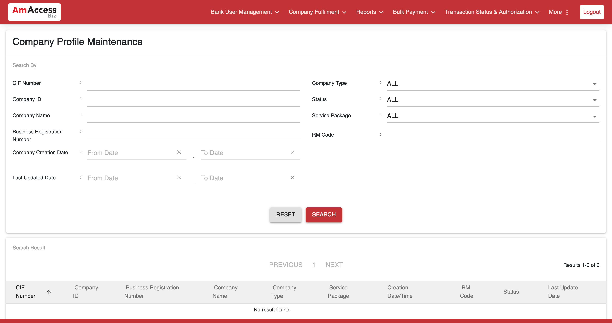  
  
**Test Step 7(PASS) :** [BBO] [Profile Maintenance] Input [Company ID]  
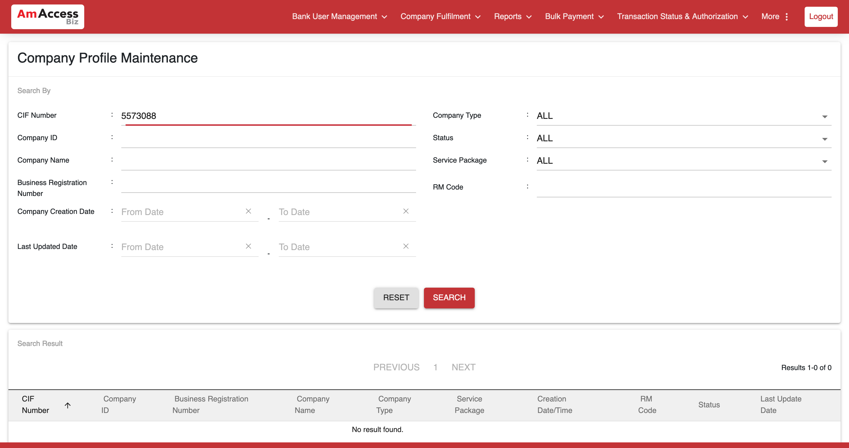  
  
**Test Step 8(PASS) :** [BBO] [Profile Maintenance[ Input [Business Reg. Number]  
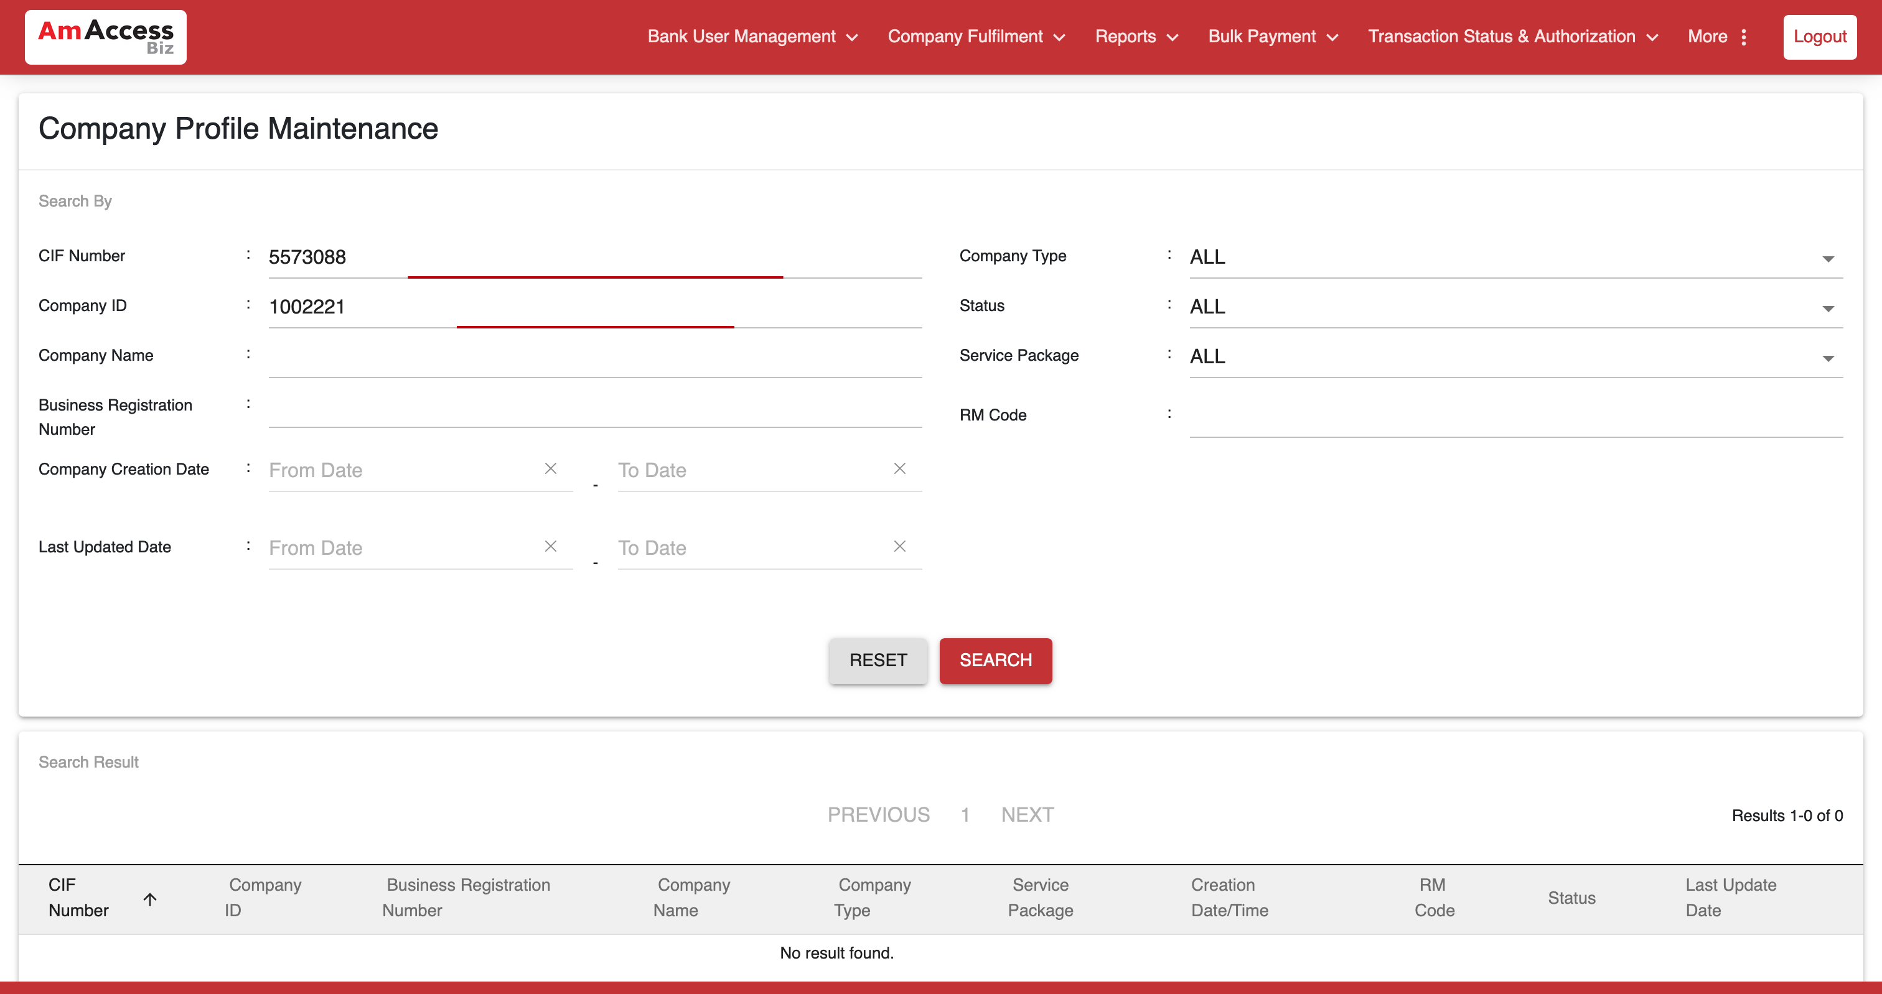  
  
**Test Step 9(PASS) :** [BBO] [Profile Maintenance] Click [Search] button  
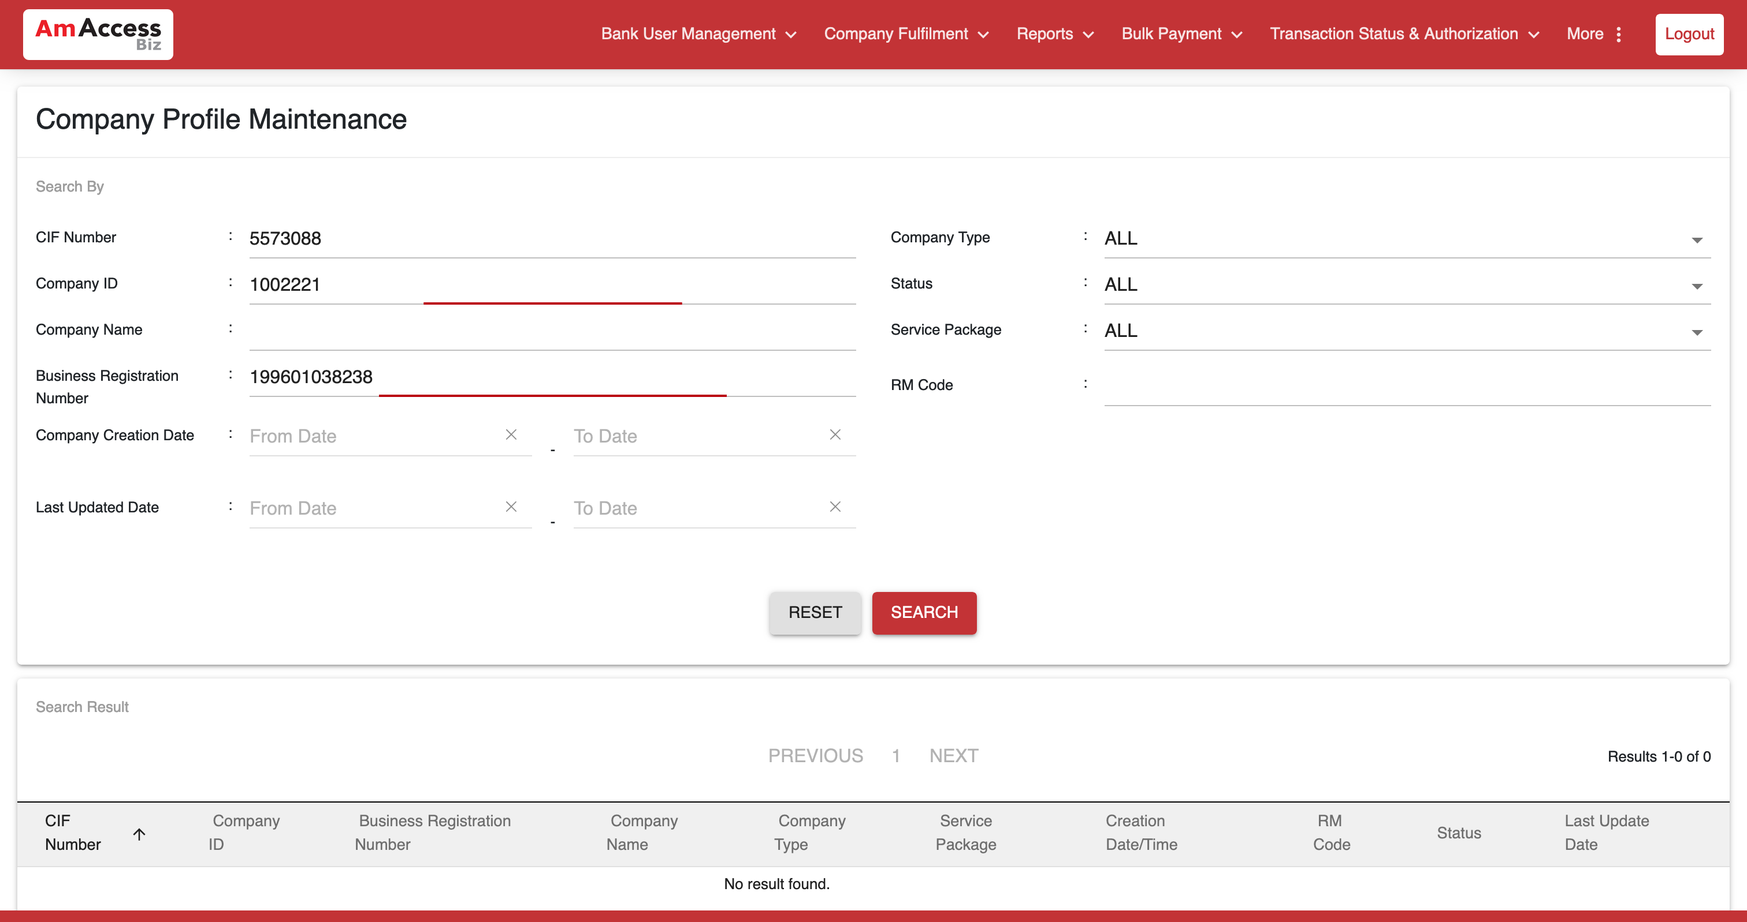  
  
**Test Step 10(PASS) :** [BBO] [Profile Maintenance] Select [Search Result]   
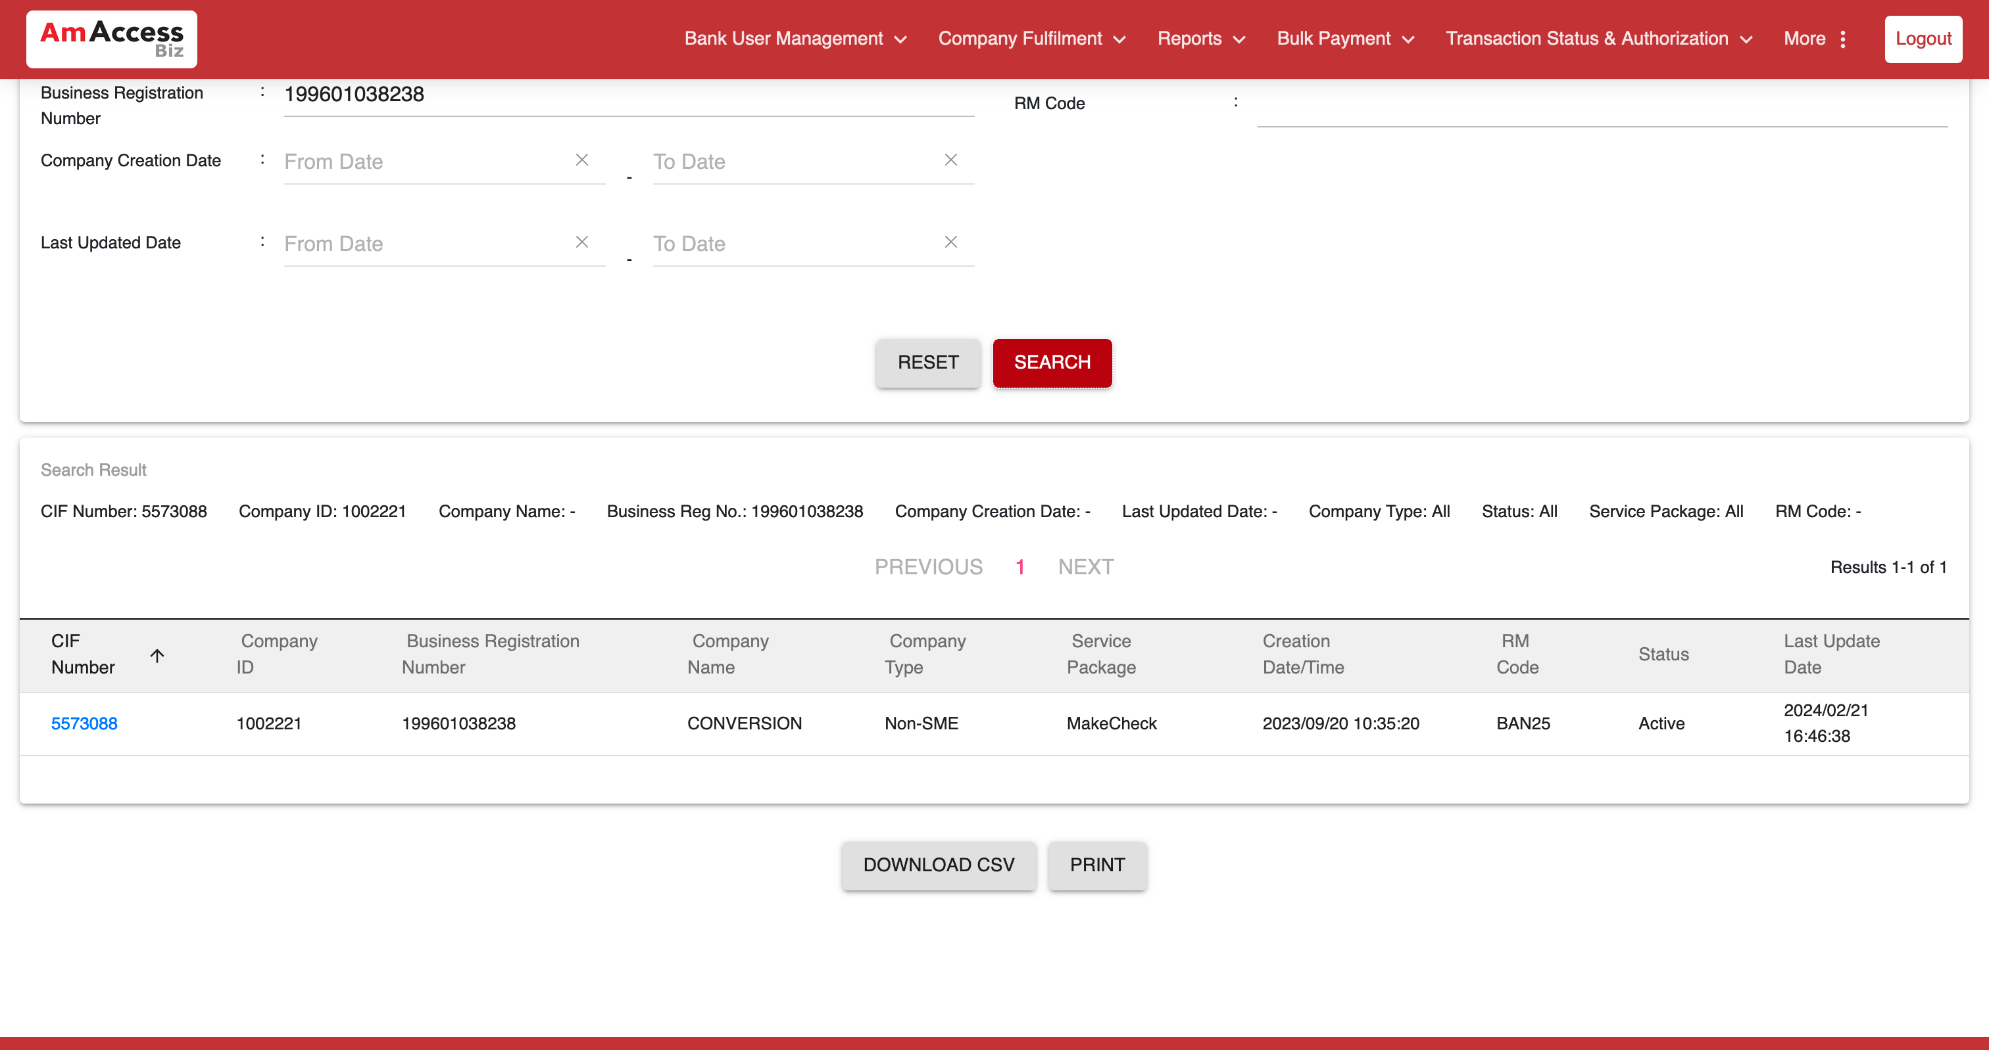  
  
**Test Step 11(PASS) :** [BBO] [Profile Information] Verify [Company Limit]  
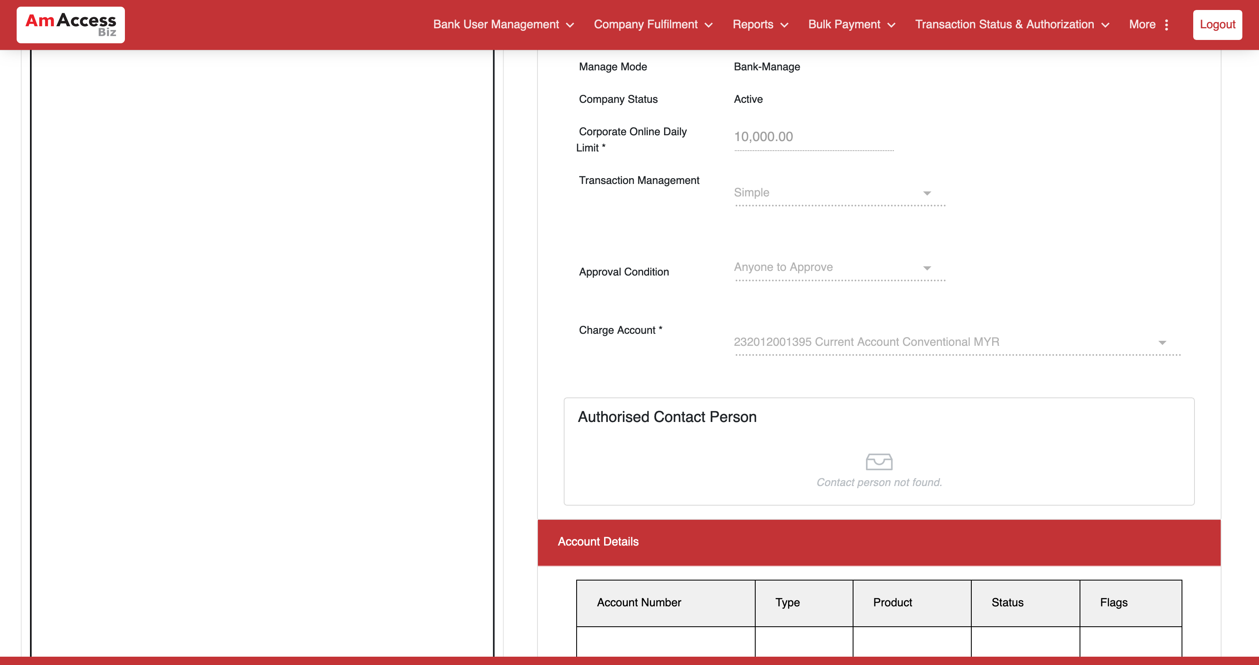  
  
**Test Step 12(PASS) :** [BBO] [Profile Information] Click [Logout]   
  
  
**Test Step 13(PASS) :** [BBO] Click [back to login]  
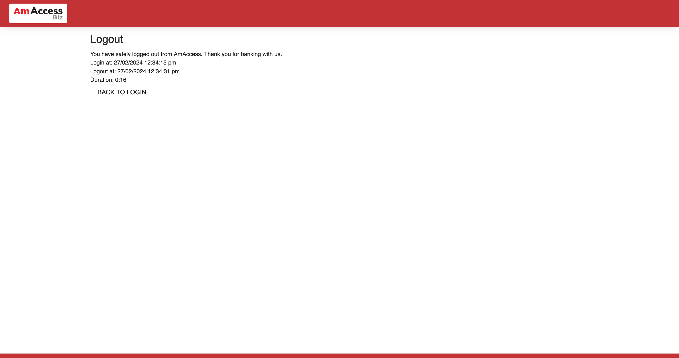  
  
**Test Step 14(PASS) :** [CFO] Input [User ID]  
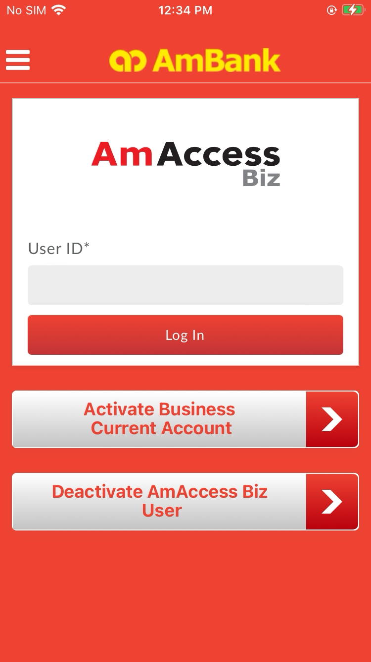  
  
**Test Step 15(PASS) :** [CFO] Click [Log In]  
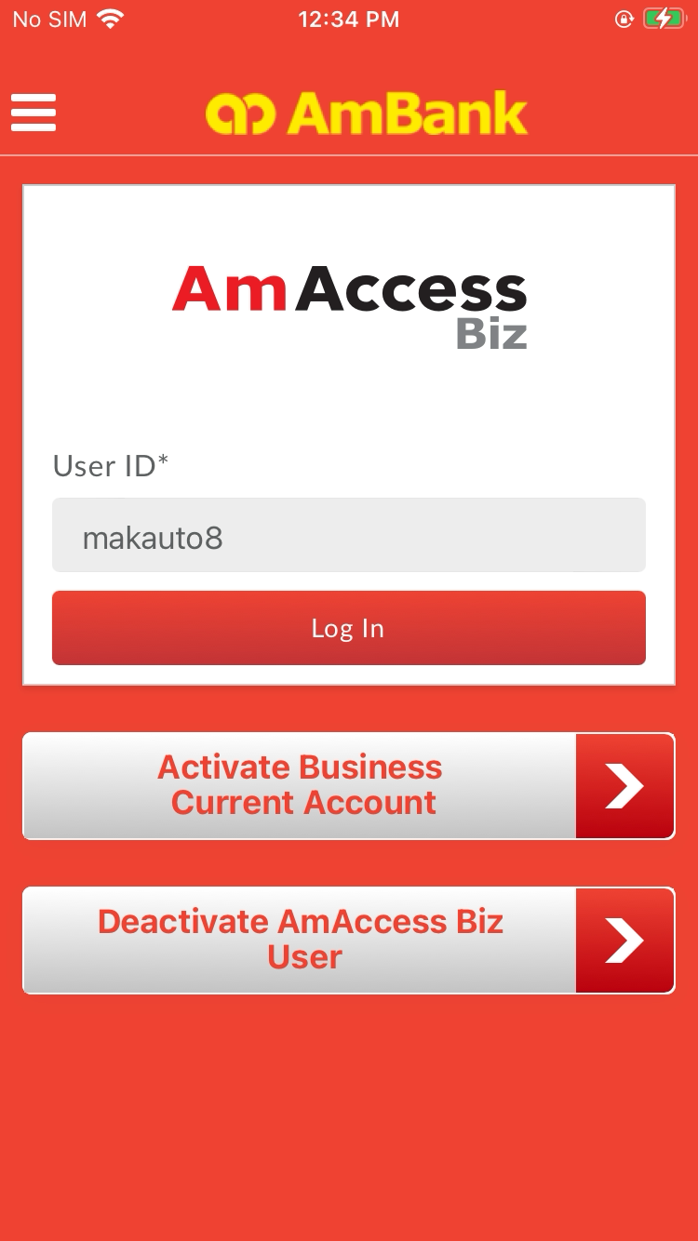  
  
**Test Step 16(PASS) :** [CFO] Click [Yes]  
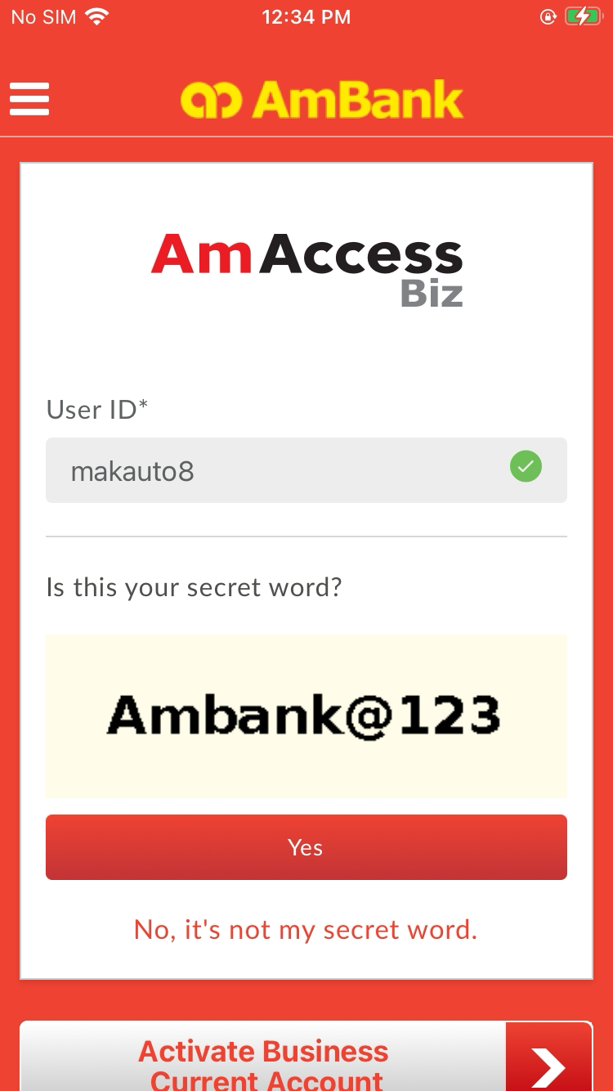  
  
**Test Step 17(PASS) :** Swipe up  
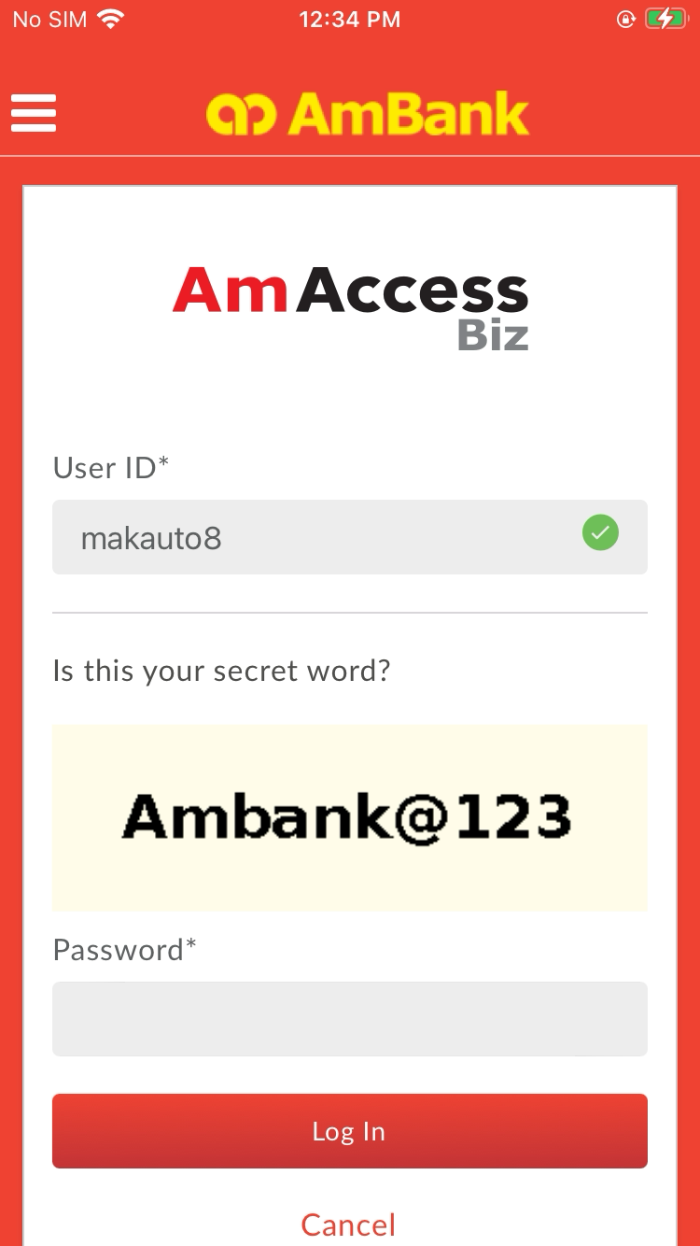  
  
**Test Step 18(PASS) :** [CFO] Input [Password]  
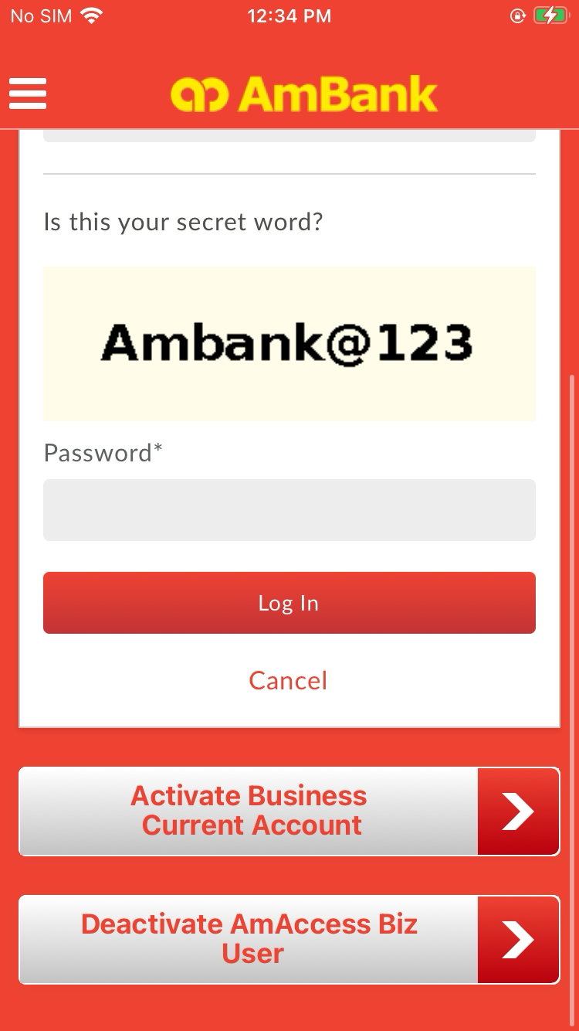  
  
**Test Step 19(PASS) :** [CFO] Click [Log In]  
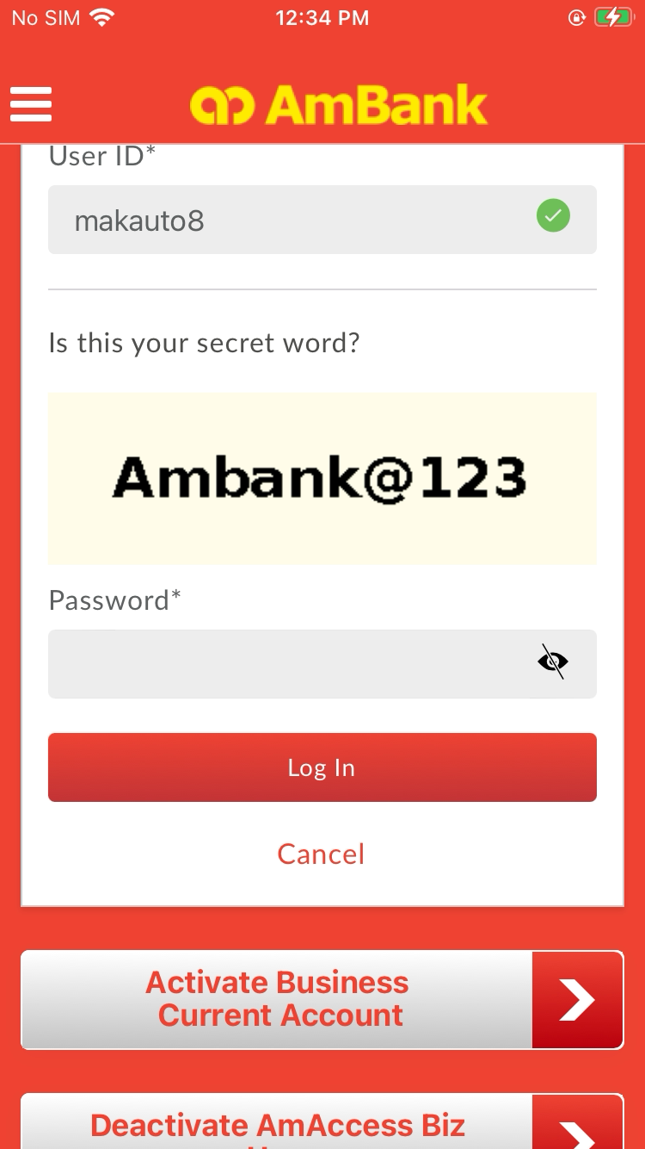  
  
**Test Step 20(PASS) :** [CFO] Click [Payment]  
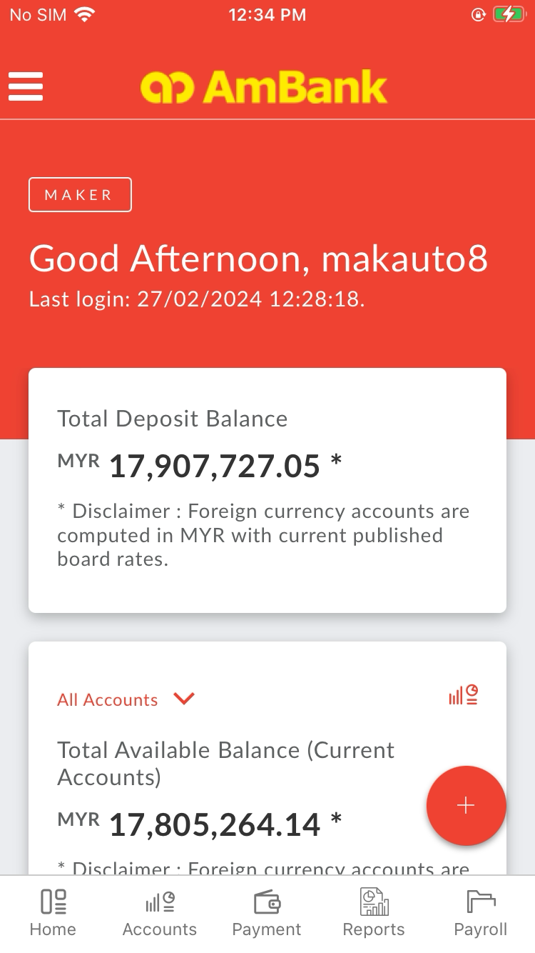  
  
**Test Step 21(PASS) :** [CFO] Click [Perform Transaction]  
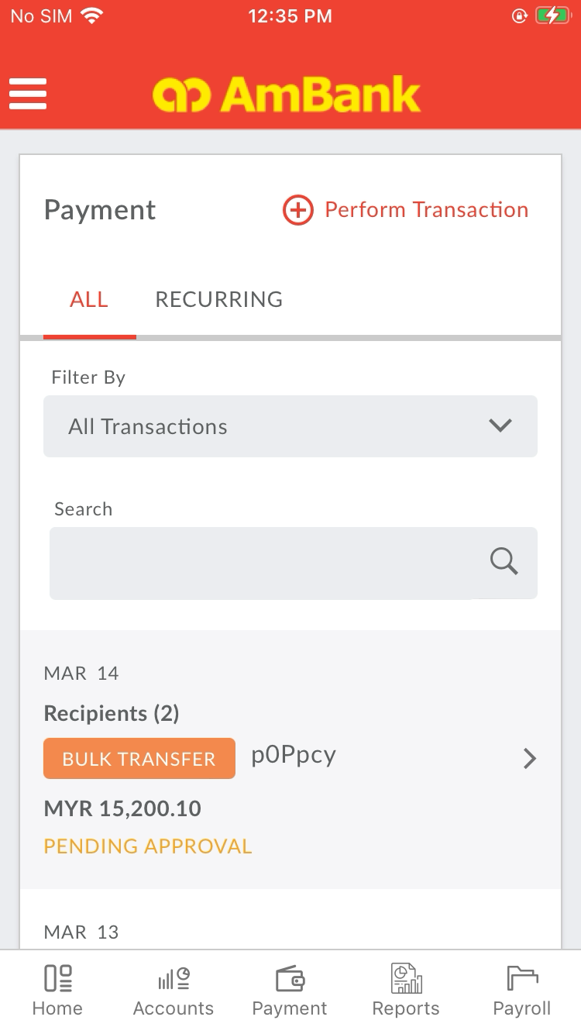  
  
**Test Step 22(PASS) :** [CFO] Click [Bill Payment]  
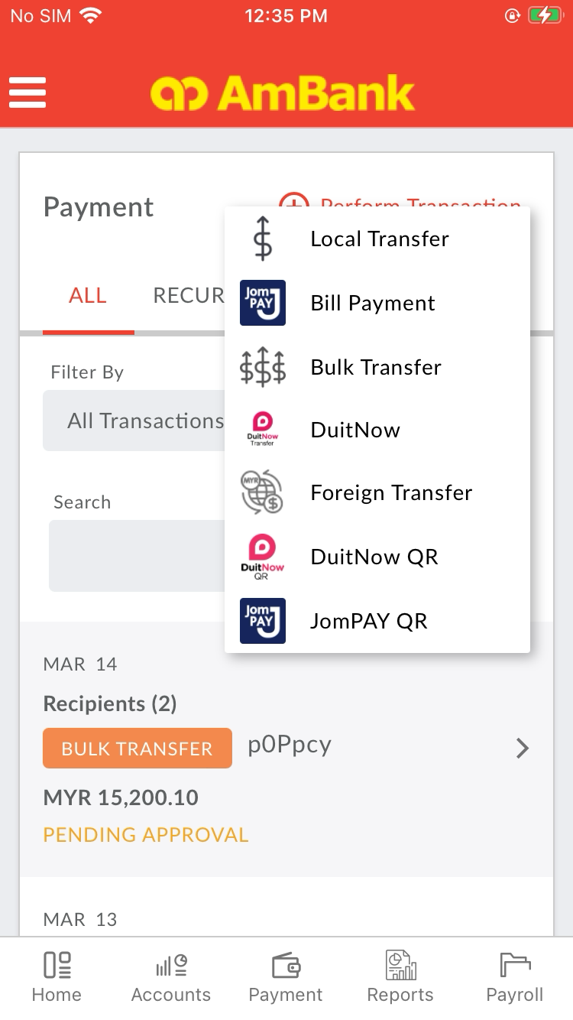  
  
**Test Step 23(PASS) :** Swipe Up To Ref 2 Optional Field  
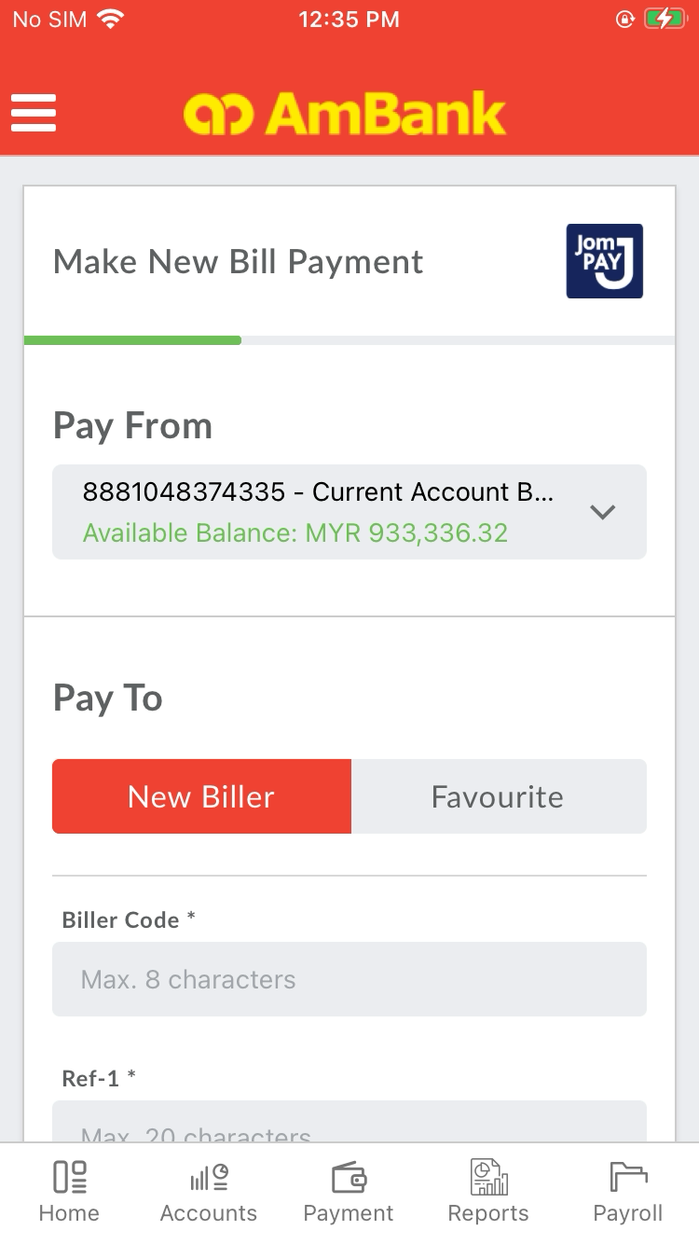  
  
**Test Step 24(PASS) :** [CFO] Input [Biller Code]  
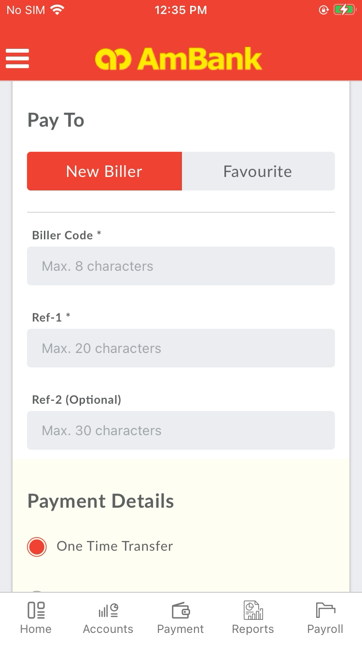  
  
**Test Step 25(PASS) :** [CFO] Click [Return Button]  
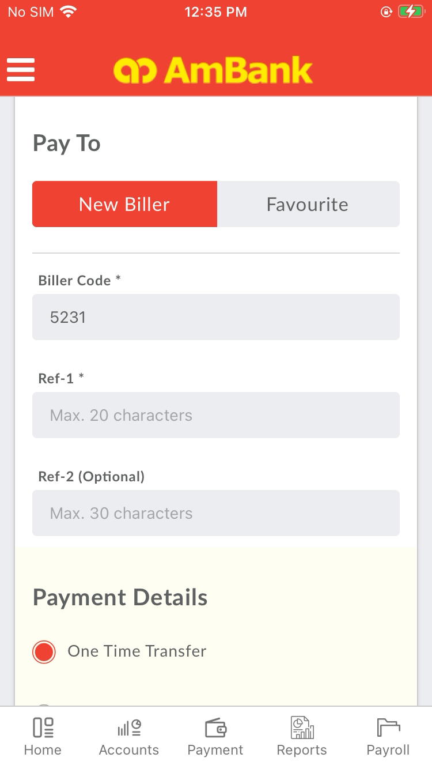  
  
**Test Step 26(PASS) :** [CFO] Input [Ref-1]  
  
  
**Test Step 27(PASS) :** [CFO] Input [Ref-2]  
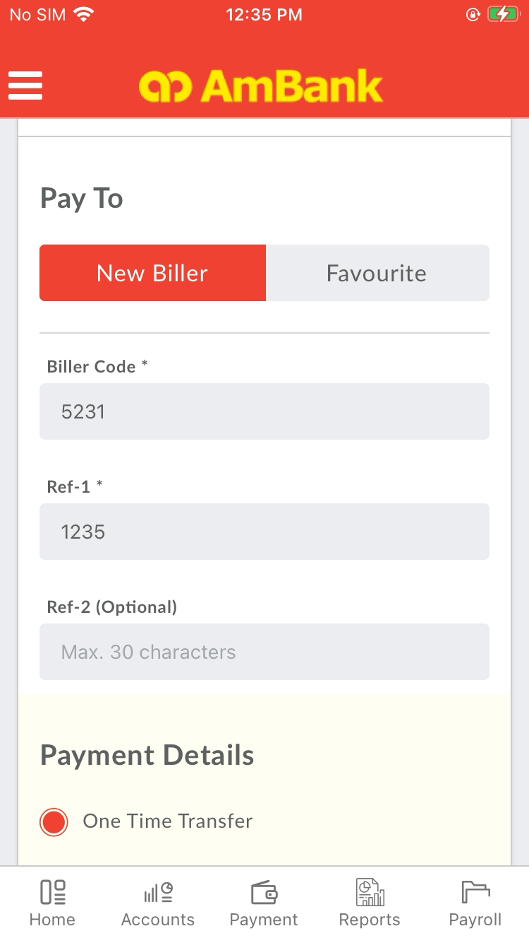  
  
**Test Step 28(PASS) :** Swipe Up to Remarks Text Field  
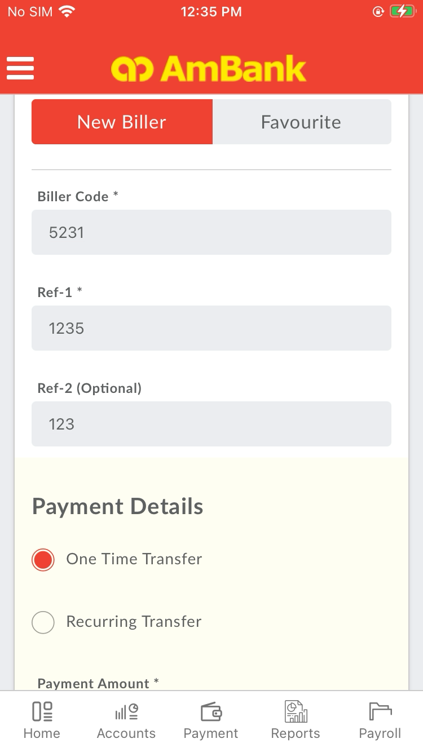  
  
**Test Step 29(PASS) :** [CFO] Input [Amount]  
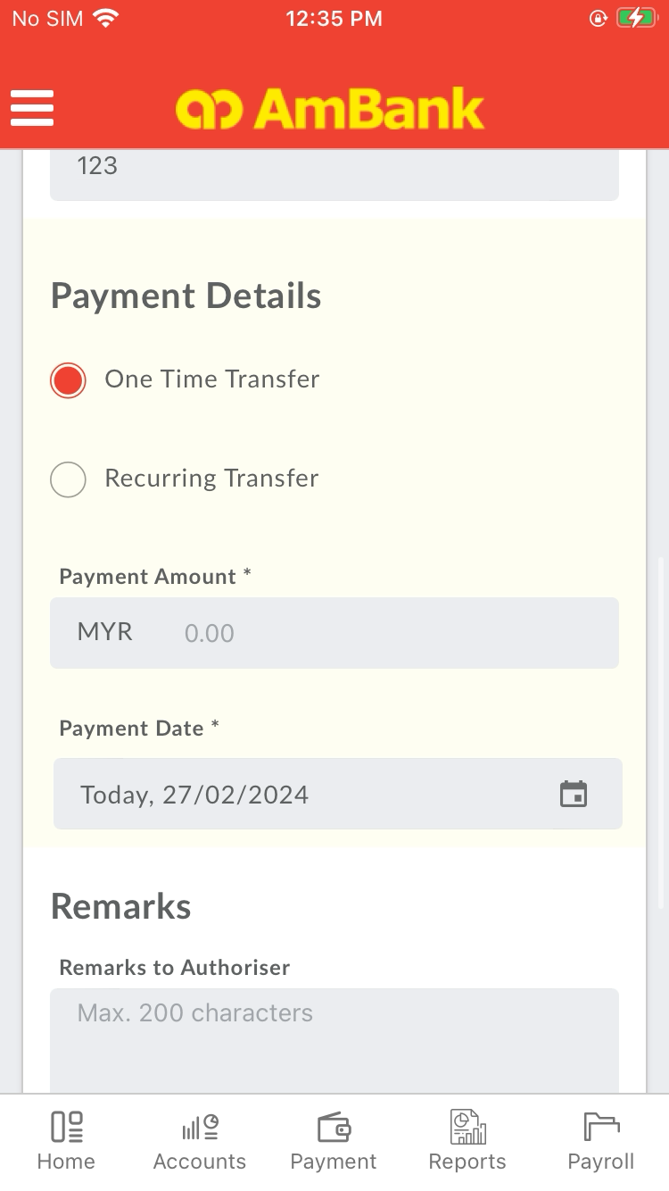  
  
**Test Step 30(PASS) :** Swipe Up to Remarks Text Field  
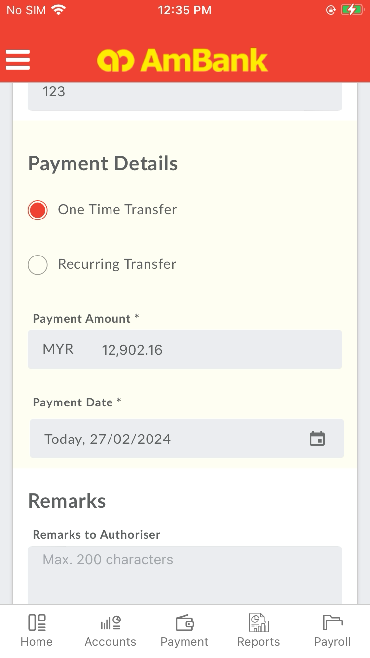  
  
**Test Step 31(PASS) :** [Make New Bill Payment] Set [Remark to Authorizer]  
  
  
**Test Step 32(PASS) :** [CFO] Click [Remarks Text Field]  
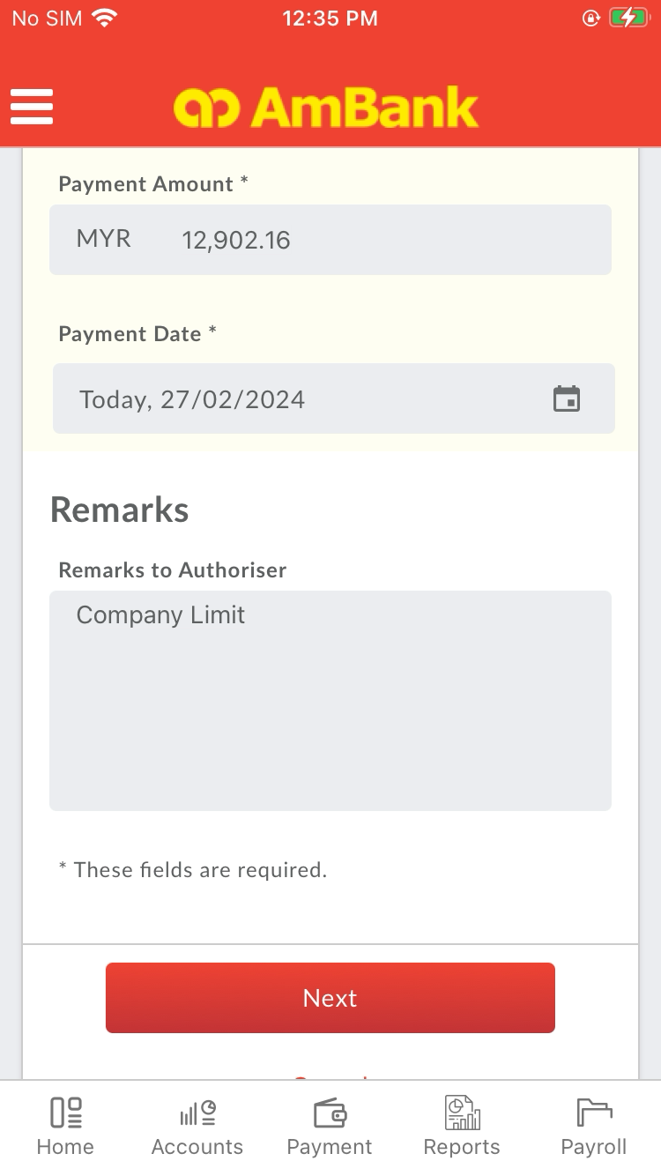  
  
**Test Step 33(PASS) :** Swipe Up to Next Button  
  
  
**Test Step 34(PASS) :** [Make New Bill Payment] Click [Next]  
  
  
**Test Step 35(PASS) :** Swipe Up To Confirm Button  
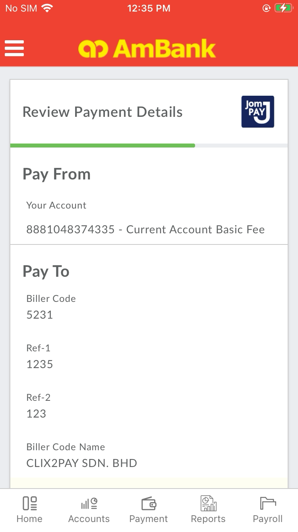  
  
**Test Step 36(PASS) :** [CFO] [Review Details] Click [Confirm] Button  
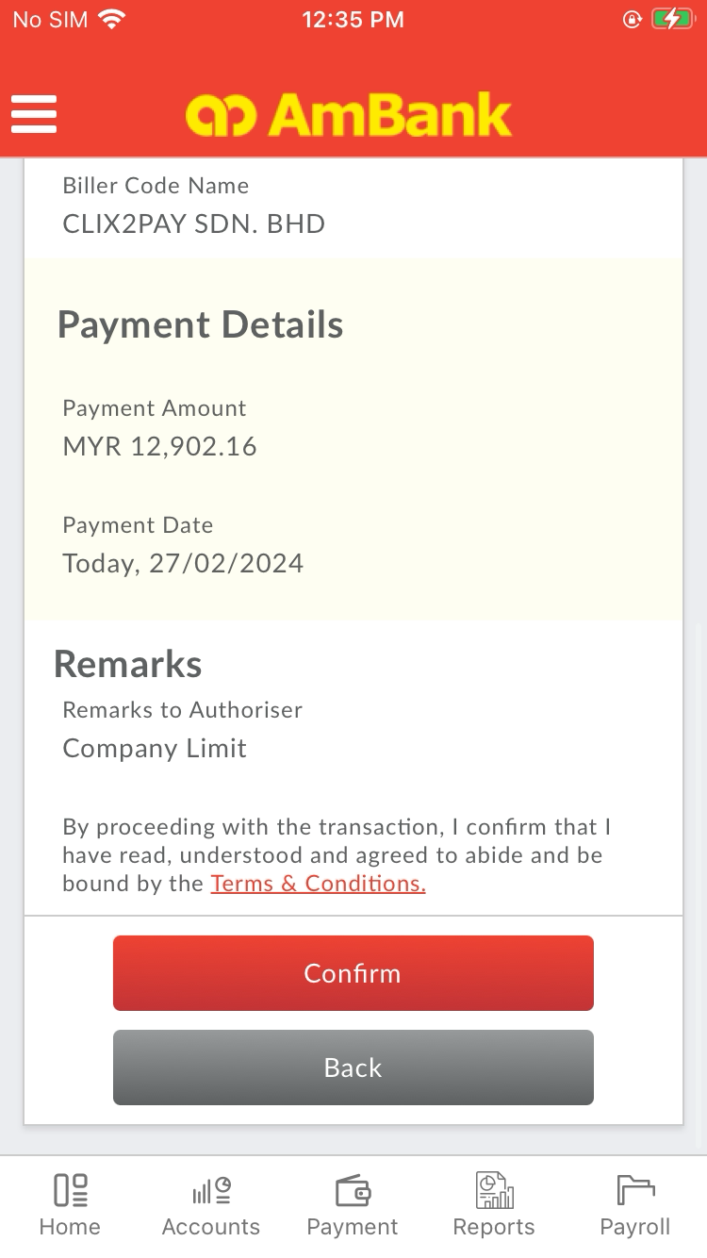  
  
**Test Step 37(PASS) :** [CFO] [Review Details] Click [Confirm] PopUp  
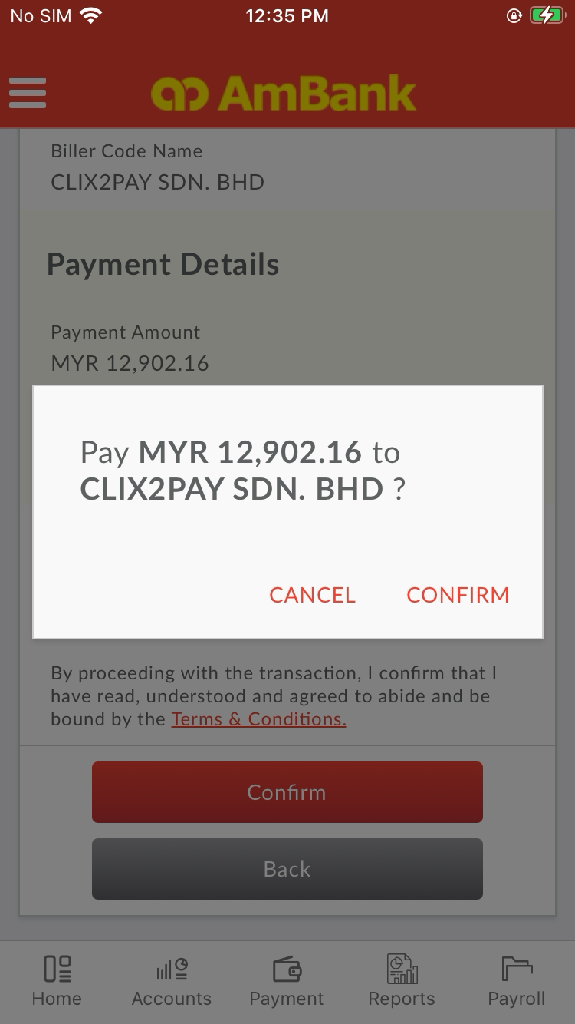  
  
**Test Step 38(PASS) :** [CFO] Verify [Transaction Status]  
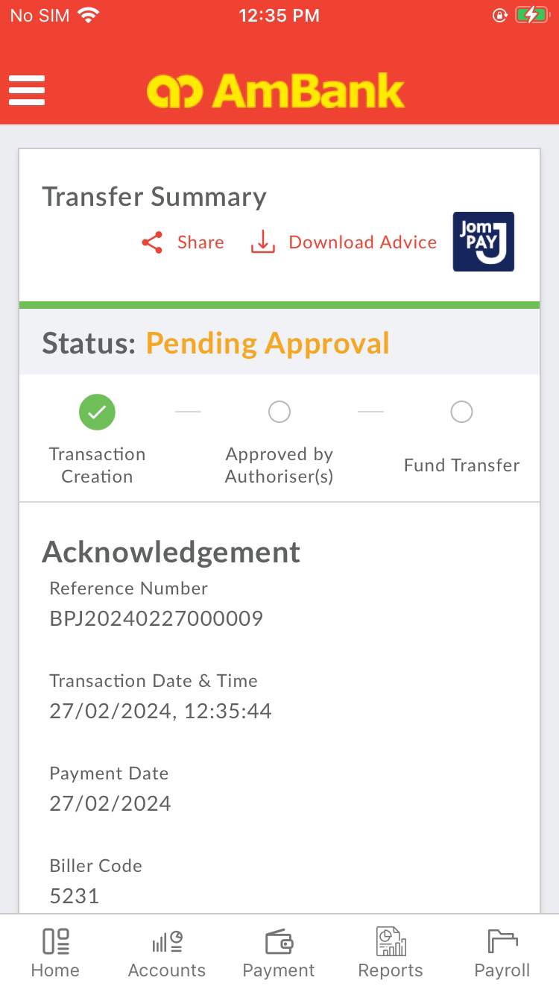  
  
**Test Step 39(PASS) :** [CFO] Capture [Reference Number]  
  
  
**Test Step 40(PASS) :** [CFO] Click [Menu]  
  
  
**Test Step 41(PASS) :** Swipe Up To LogOut  
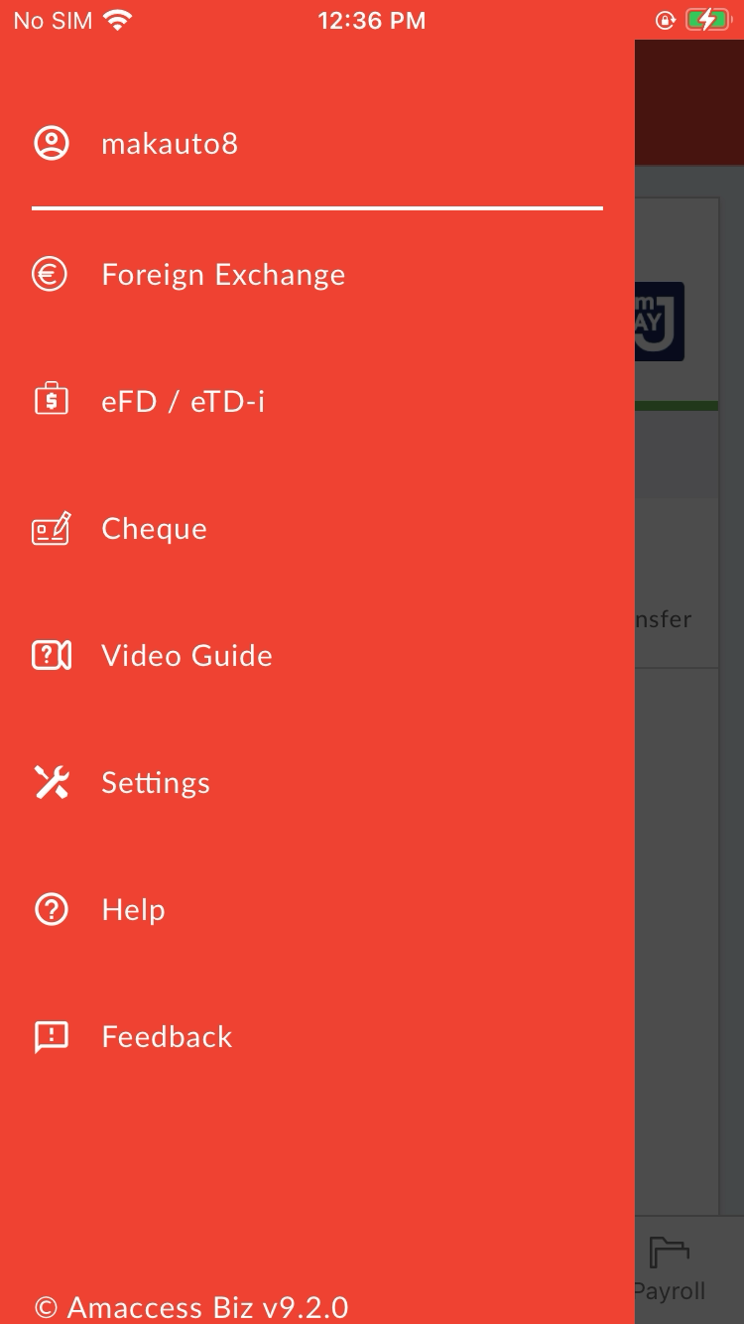  
  
**Test Step 42(PASS) :** [CFO] Click [Logout]  
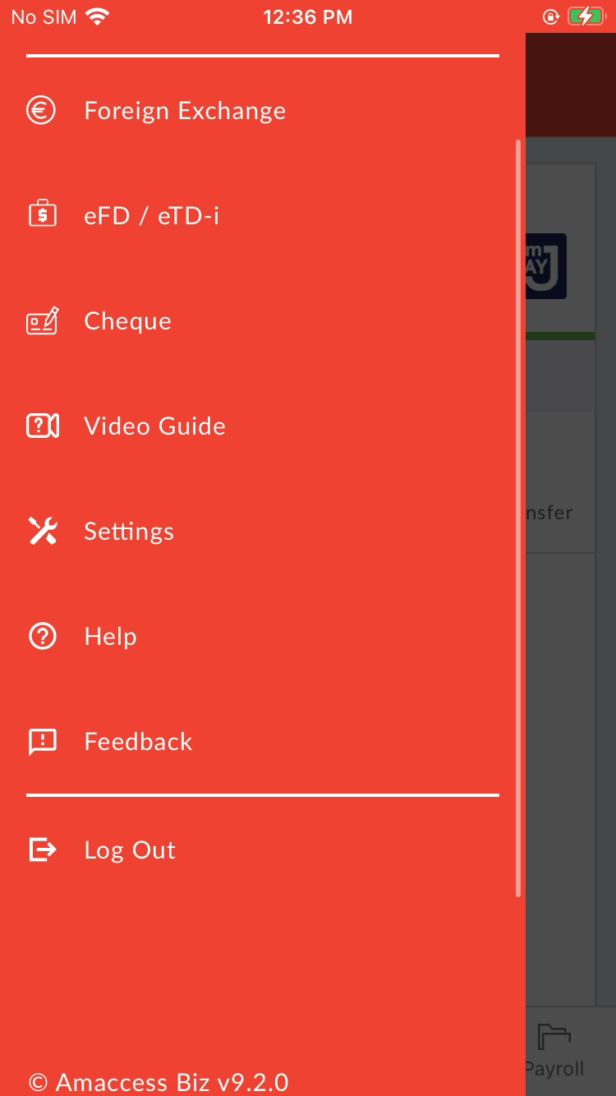  
  
**Test Step 43(PASS) :** [CFO] Click [Menu]  
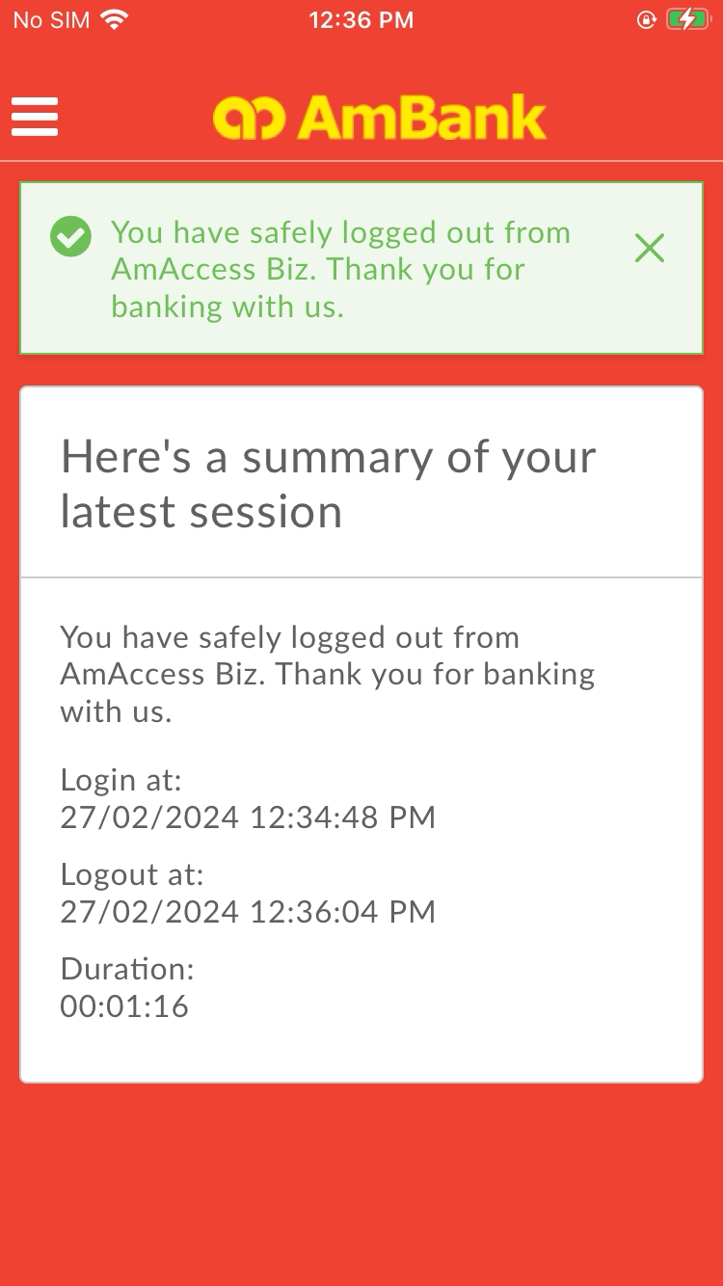  
  
**Test Step 44(PASS) :** [CFO] Click [Log In]  
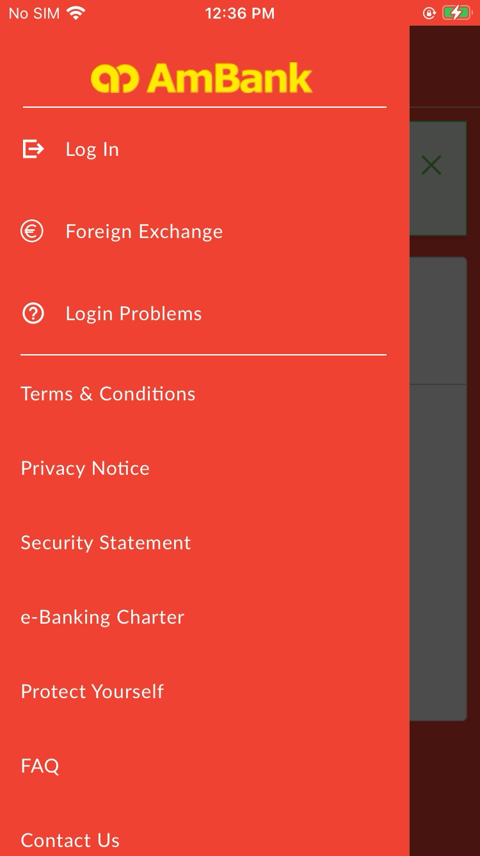  
  
**Test Step 45(PASS) :** [CFO] Input [User ID]  
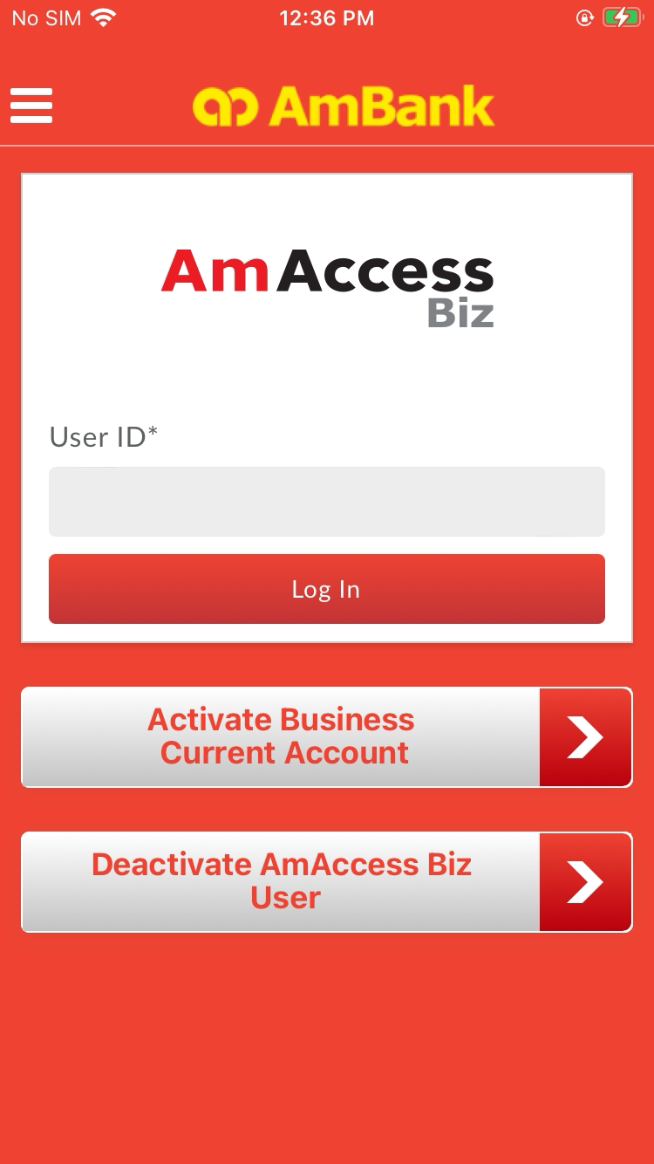  
  
**Test Step 46(PASS) :** [CFO] Click [Log In]  
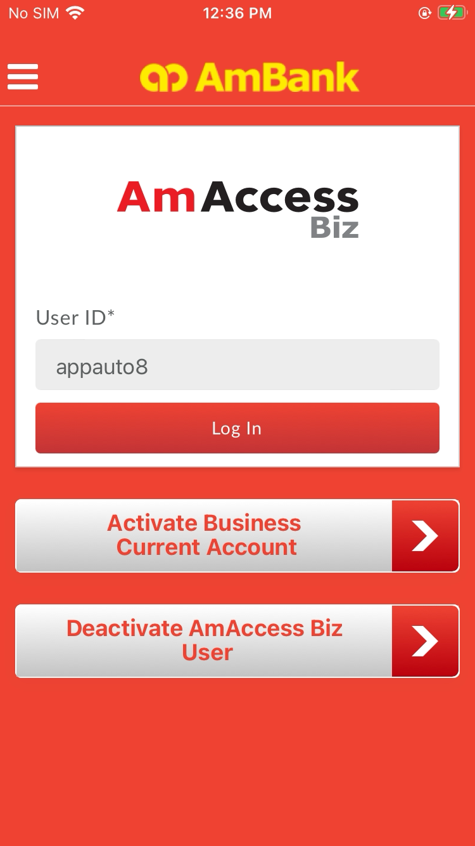  
  
**Test Step 47(PASS) :** [CFO] Click [Yes]  
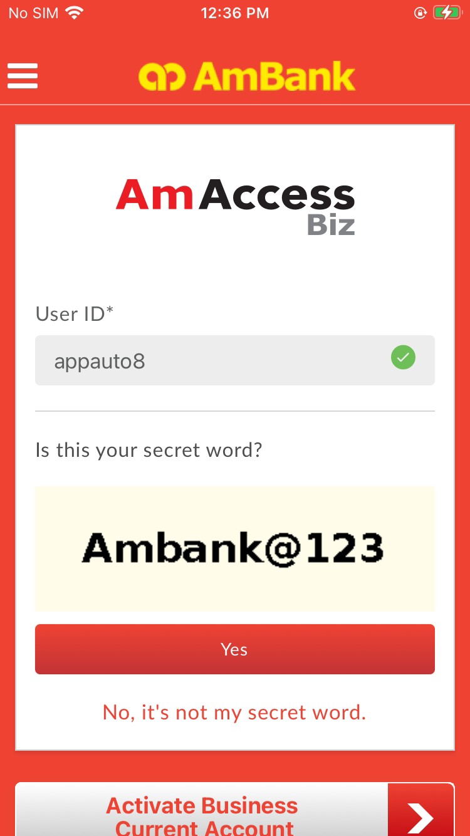  
  
**Test Step 48(PASS) :** Swipe up  
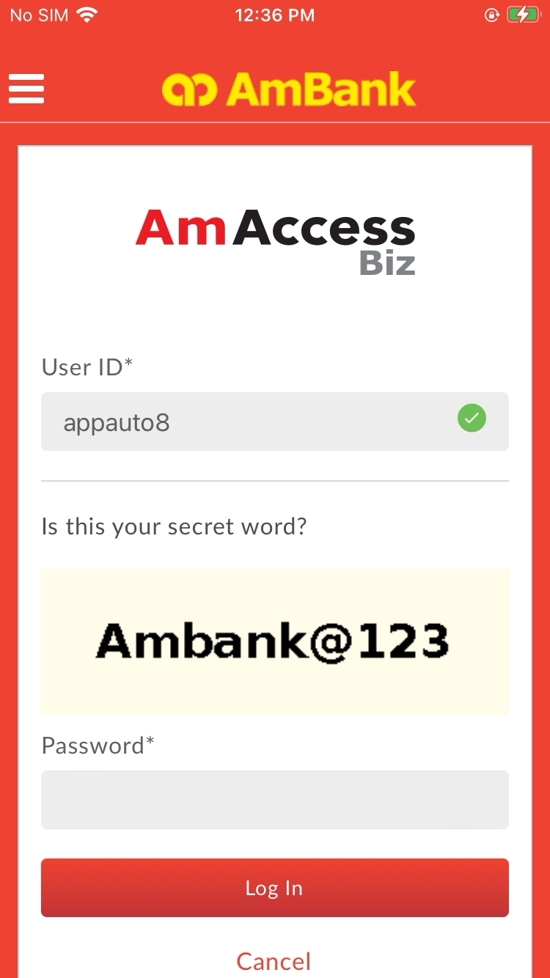  
  
**Test Step 49(PASS) :** [CFO] Input [Password]  
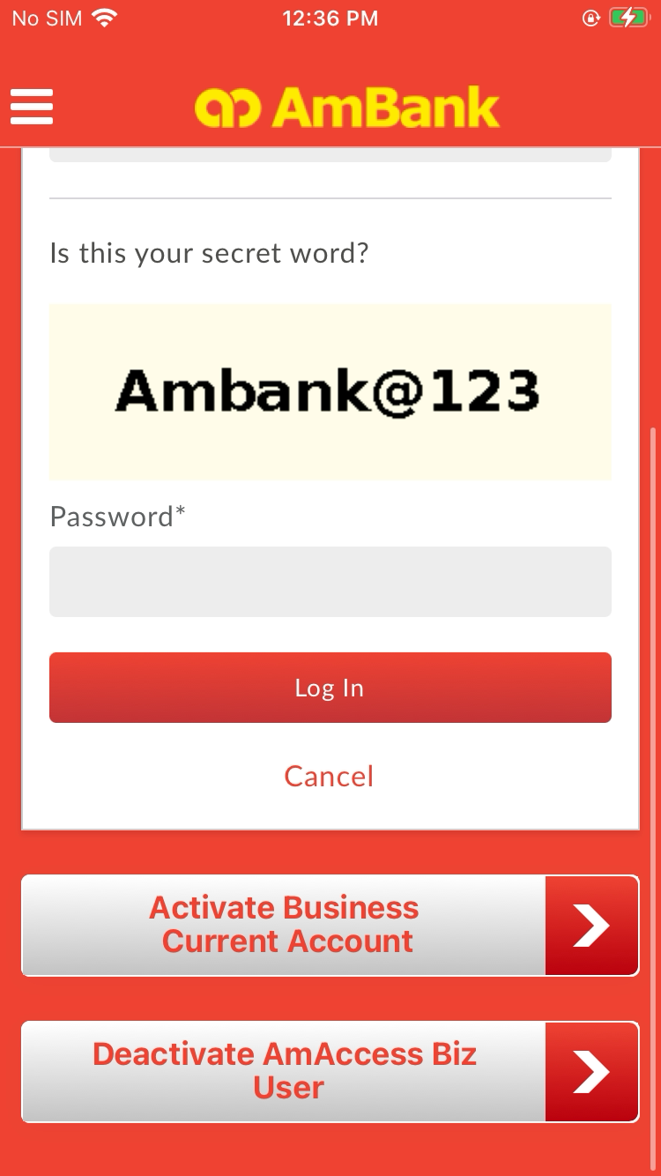  
  
**Test Step 50(PASS) :** [CFO] Click [Log In]  
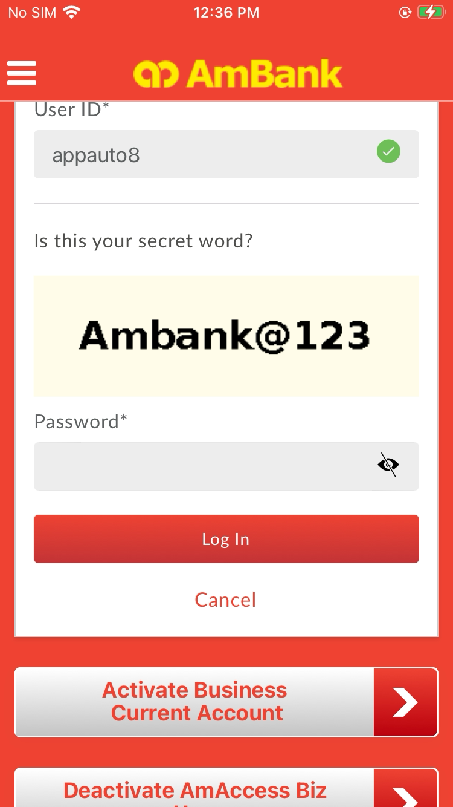  
  
**Test Step 51(PASS) :** [CFO] Click [Payment]  
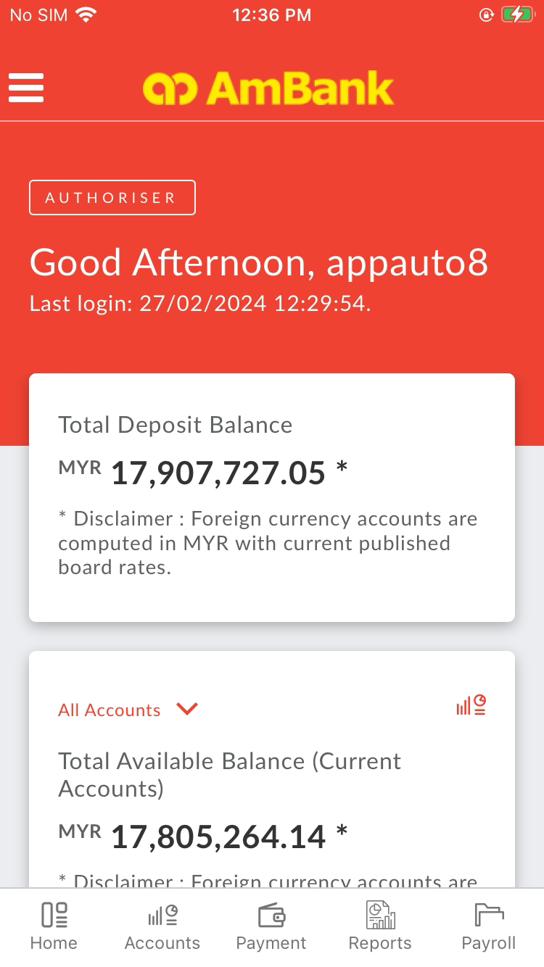  
  
**Test Step 52(PASS) :** [Local Transfer] Click [ALL]  
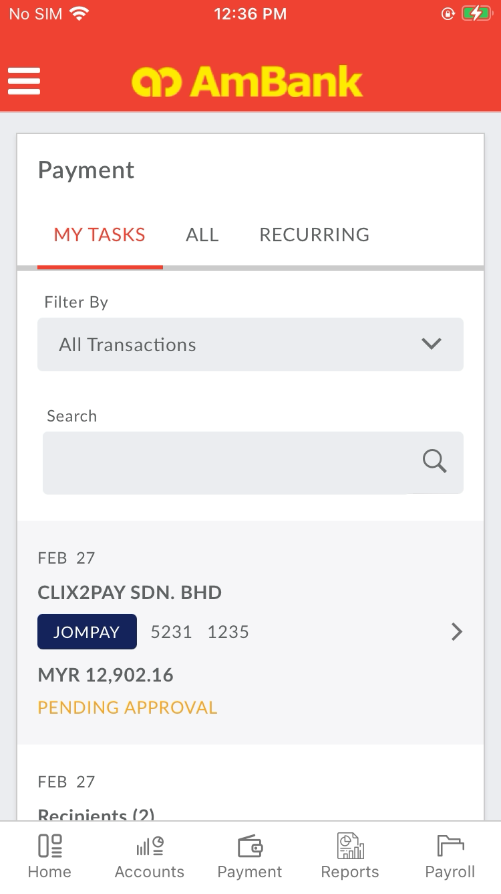  
  
**Test Step 53(PASS) :** [Local Transfer] Click [All Transactions Filter]  
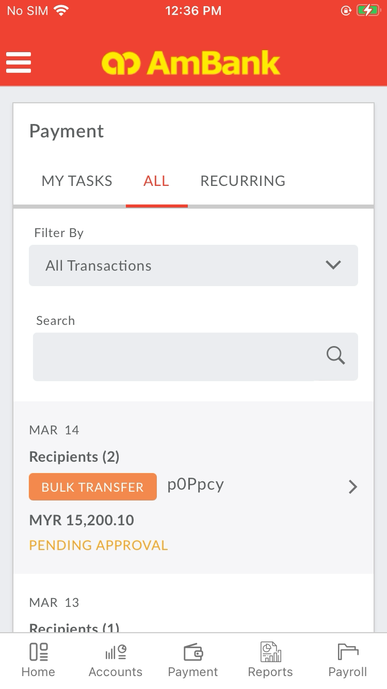  
  
**Test Step 54(PASS) :** [Local Transfer] Click [Today]  
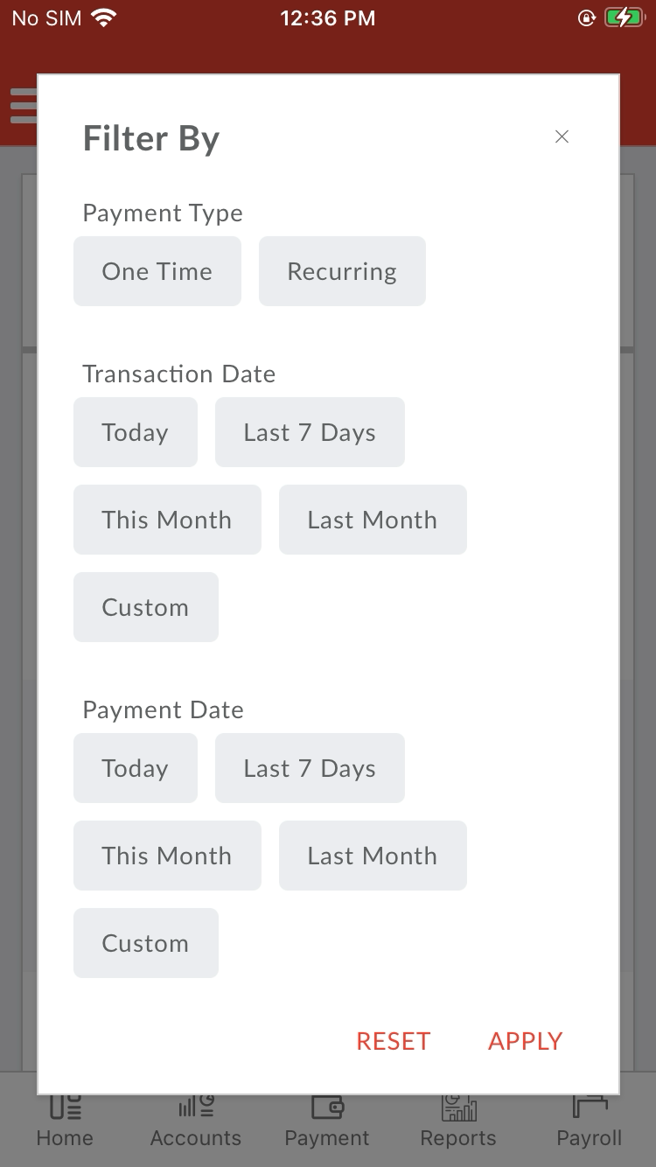  
  
**Test Step 55(PASS) :** Swipe Up To Transaction Type  
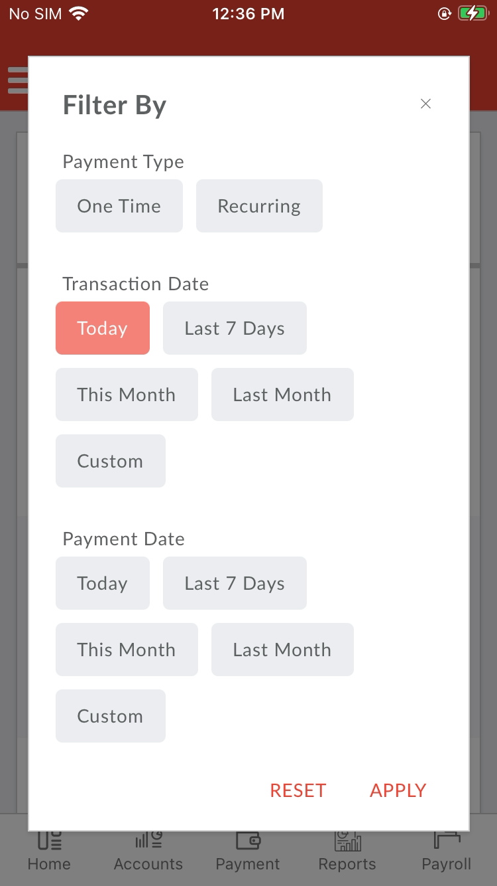  
  
**Test Step 56(PASS) :** [Local Transfer] Click [Bill]  
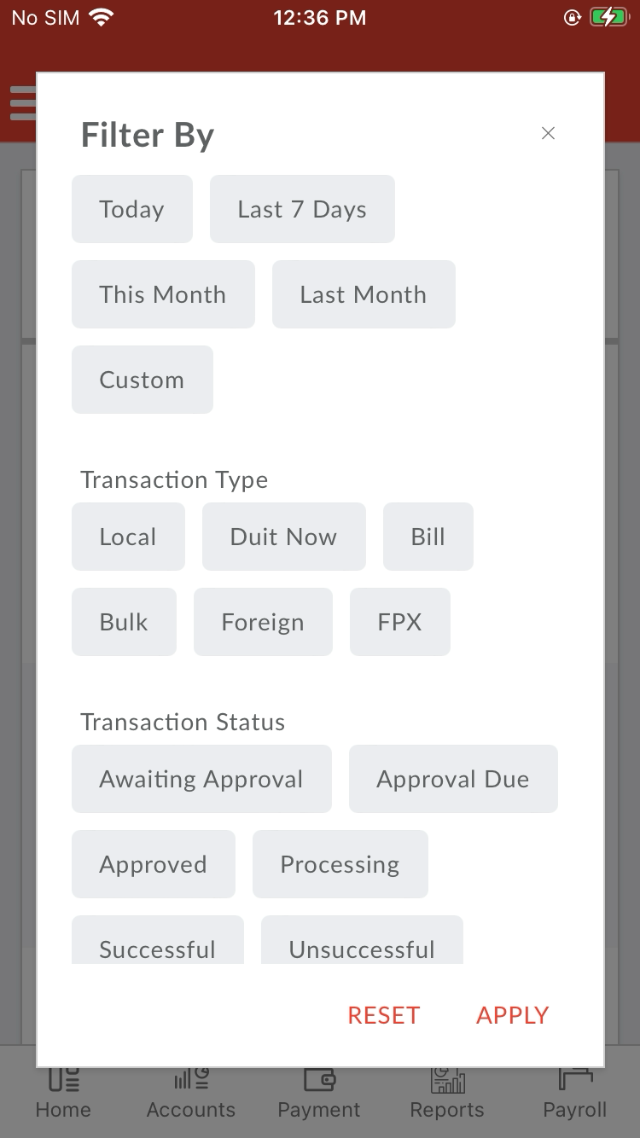  
  
**Test Step 57(PASS) :** Swipe Up To Transaction Status  
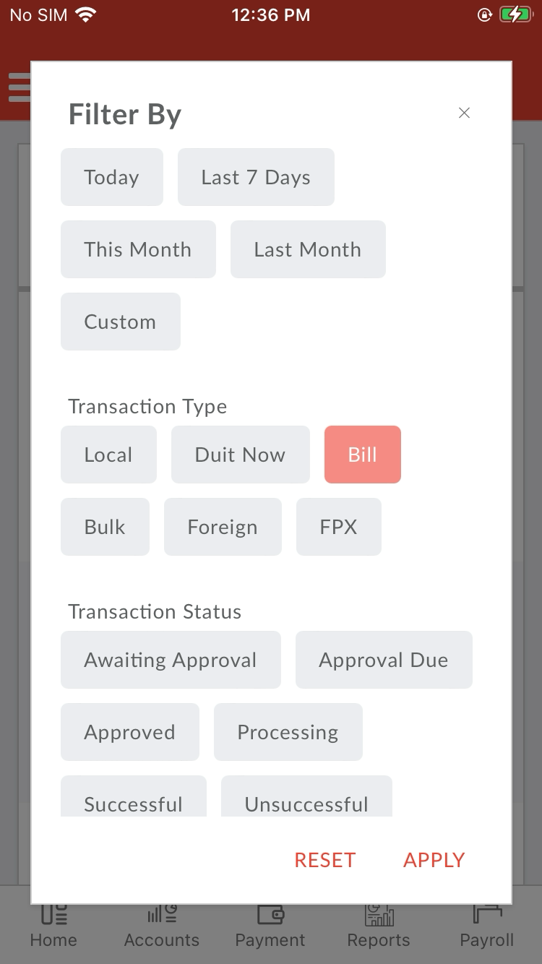  
  
**Test Step 58(PASS) :** [Local Transfer] Click [Awaiting Approval]  
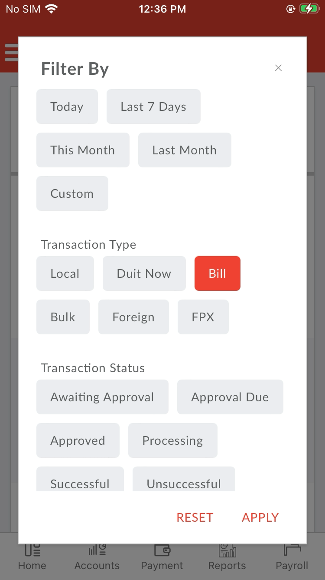  
  
**Test Step 59(PASS) :** [Local Transfer] Click [Apply]  
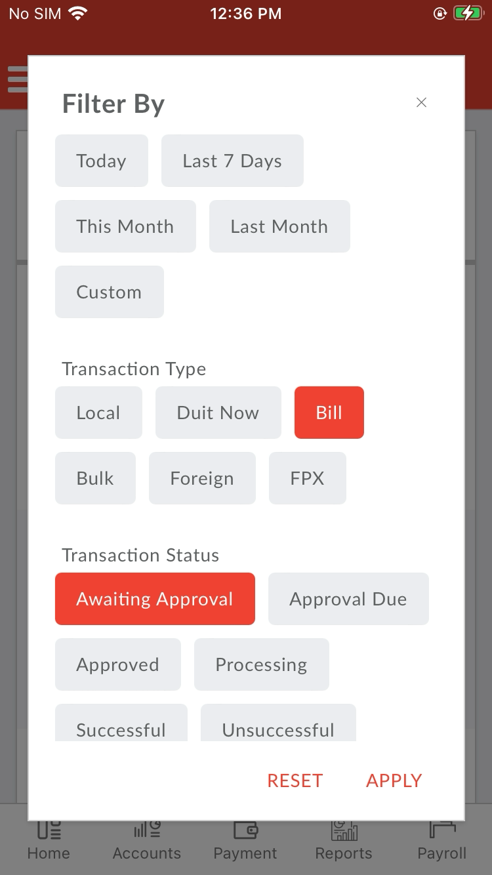  
  
**Test Step 60(PASS) :** Swipe Up To Transaction   
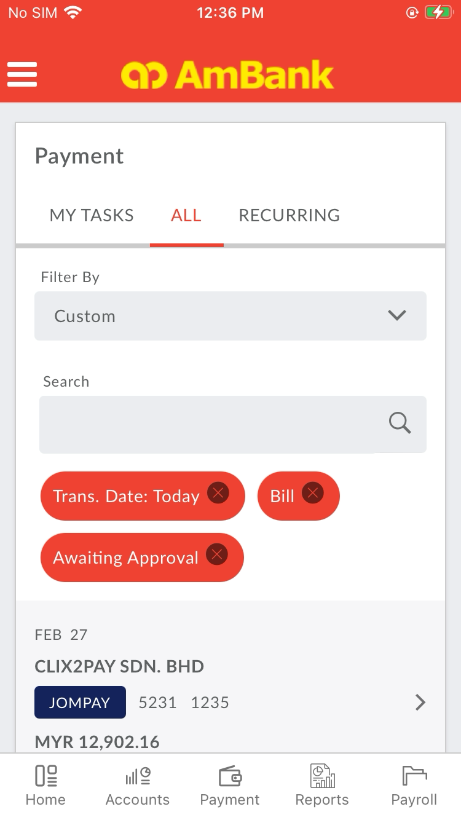  
  
**Test Step 61(PASS) :** [CFO] Click [Transaction]  
  
  
**Test Step 62(PASS) :** [CFO] Verify [Reference Number]  
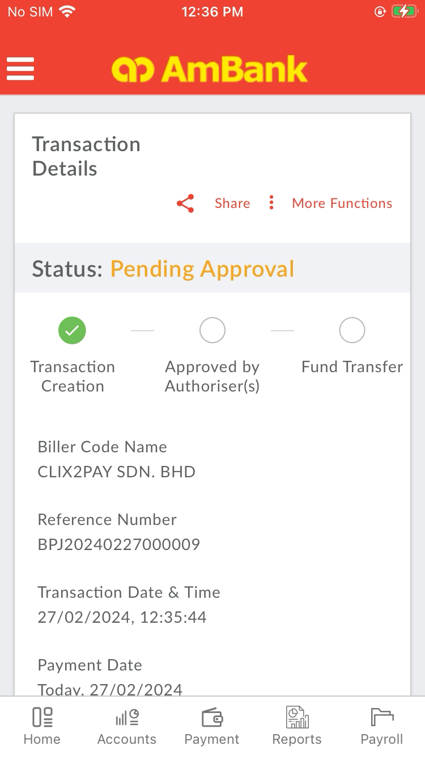  
  
**Test Step 63(PASS) :** Swipe Up To [Approve Button]  
  
  
**Test Step 64(PASS) :** [CFO] Click [Approve]  
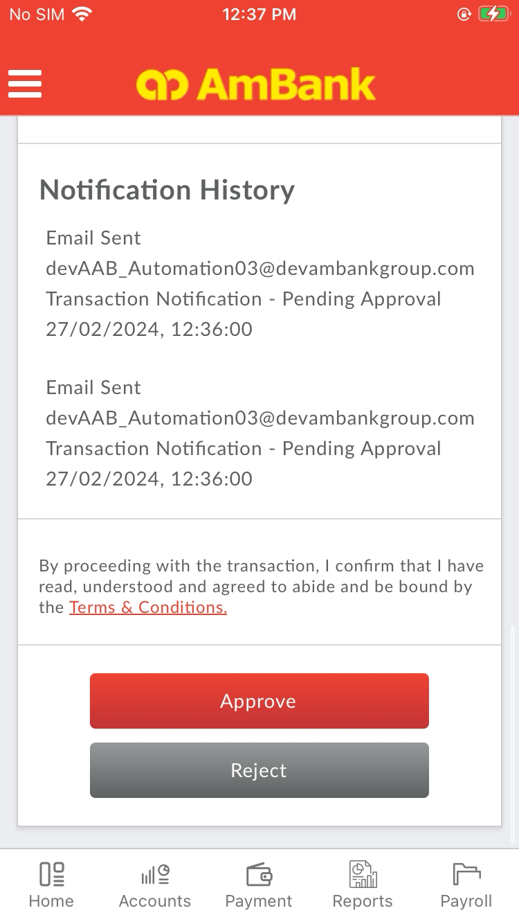  
  
**Test Step 65(PASS) :** Swipe Up To [Approve Button]  
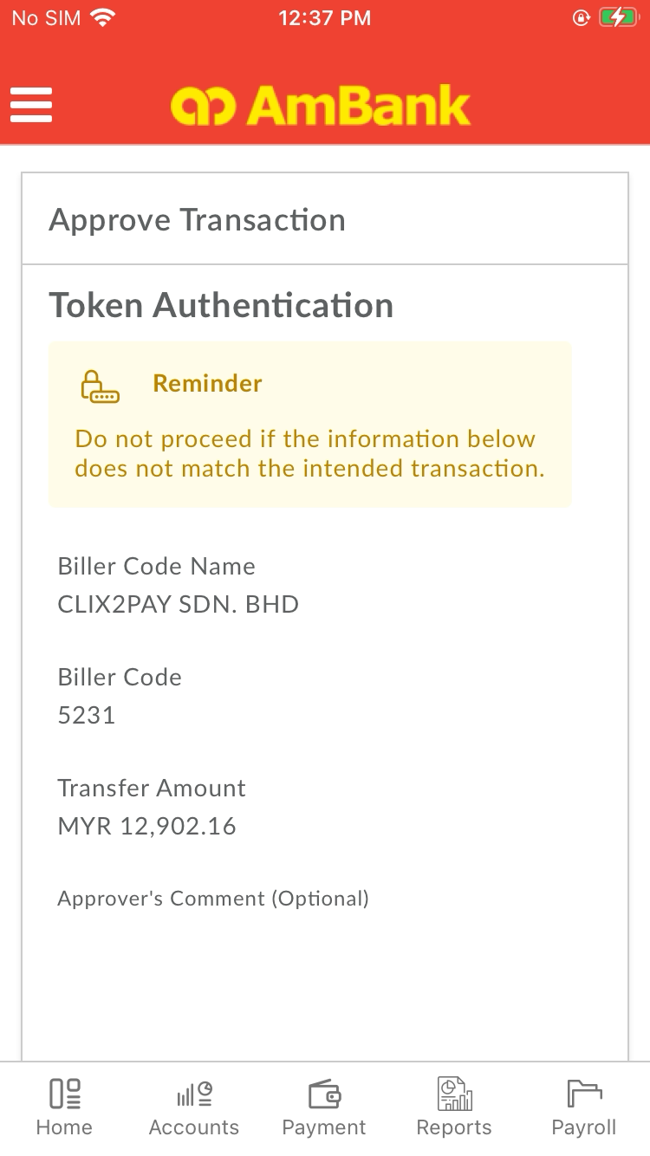  
  
**Test Step 66(PASS) :** [CFO] Set [Authorizer Comment]  
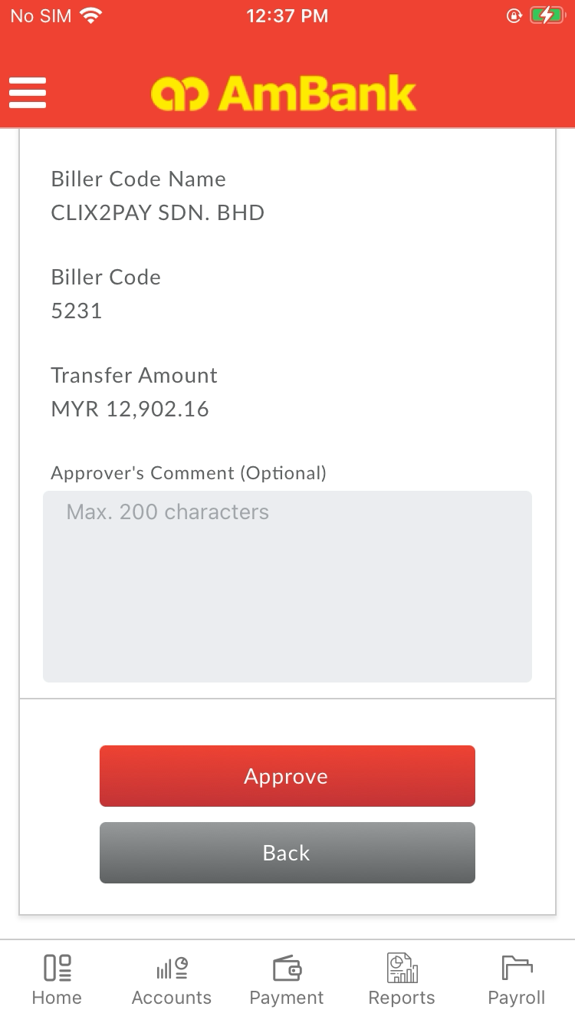  
  
**Test Step 67(PASS) :** [CFO] Click [Authorizer Comment Text Field]  
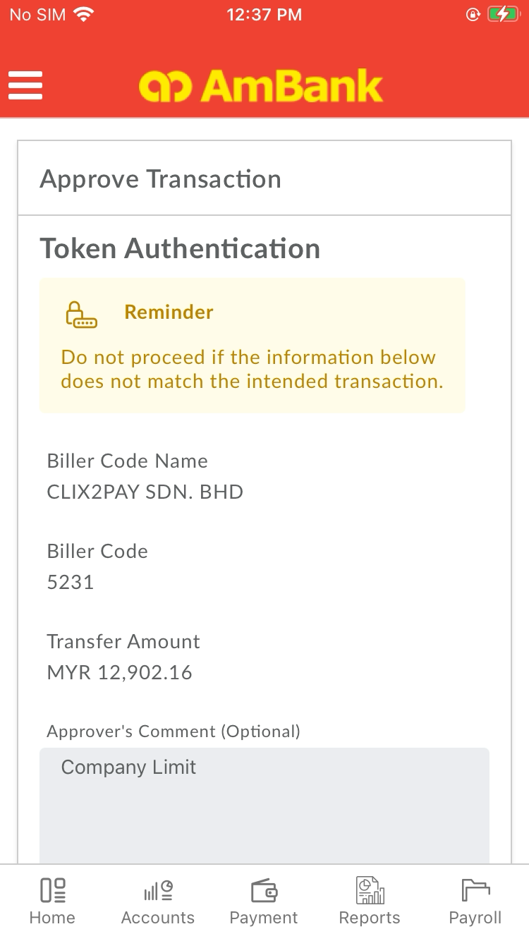  
  
**Test Step 68(PASS) :** Swipe Up To [Approve Button]  
  
  
**Test Step 69(PASS) :** [CFO] Click [Approve]  
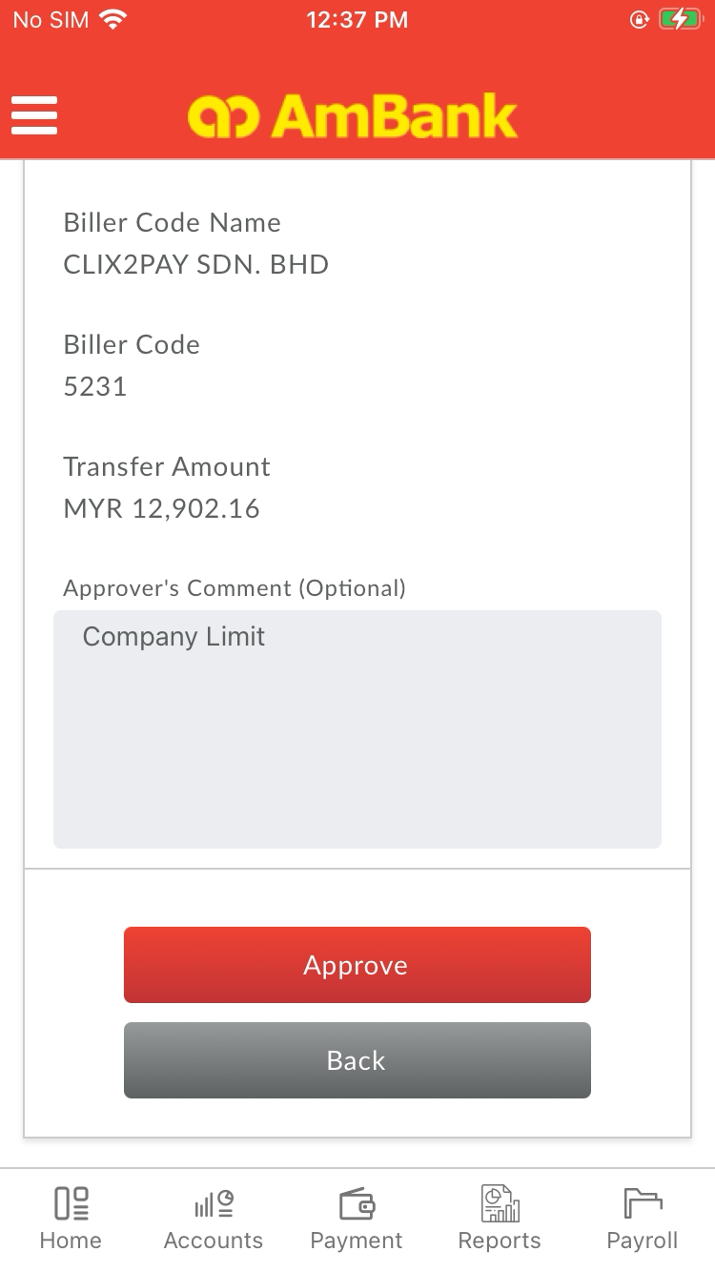  
  
**Test Step 70(PASS) :** [Digital Token] Click [PIN]  
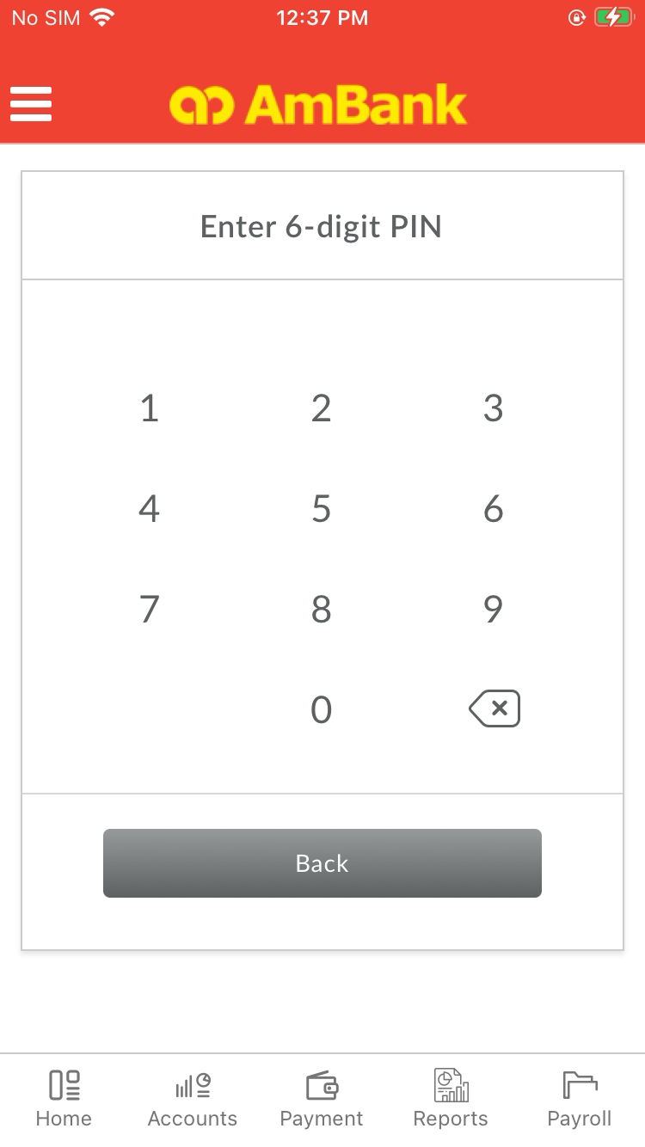  
  
**Test Step 71(PASS) :** [Digital Token] Click [PIN]  
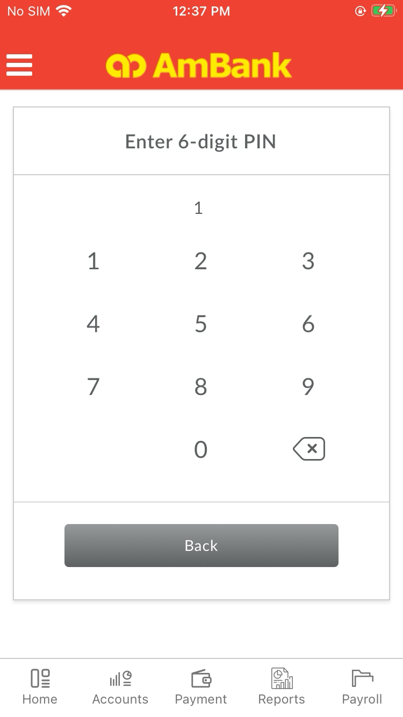  
  
**Test Step 72(PASS) :** [Digital Token] Click [PIN]  
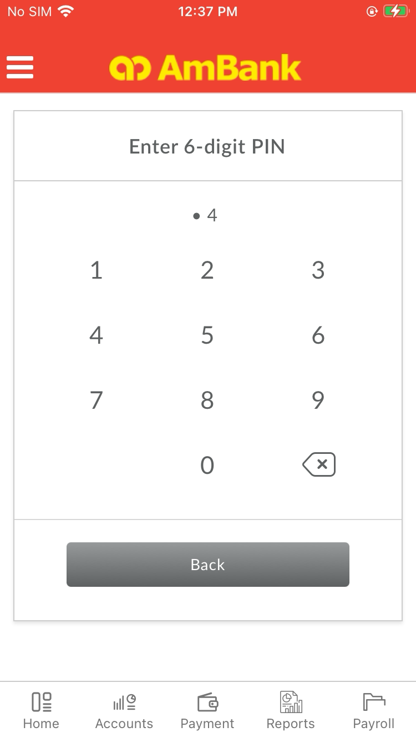  
  
**Test Step 73(PASS) :** [Digital Token] Click [PIN]  
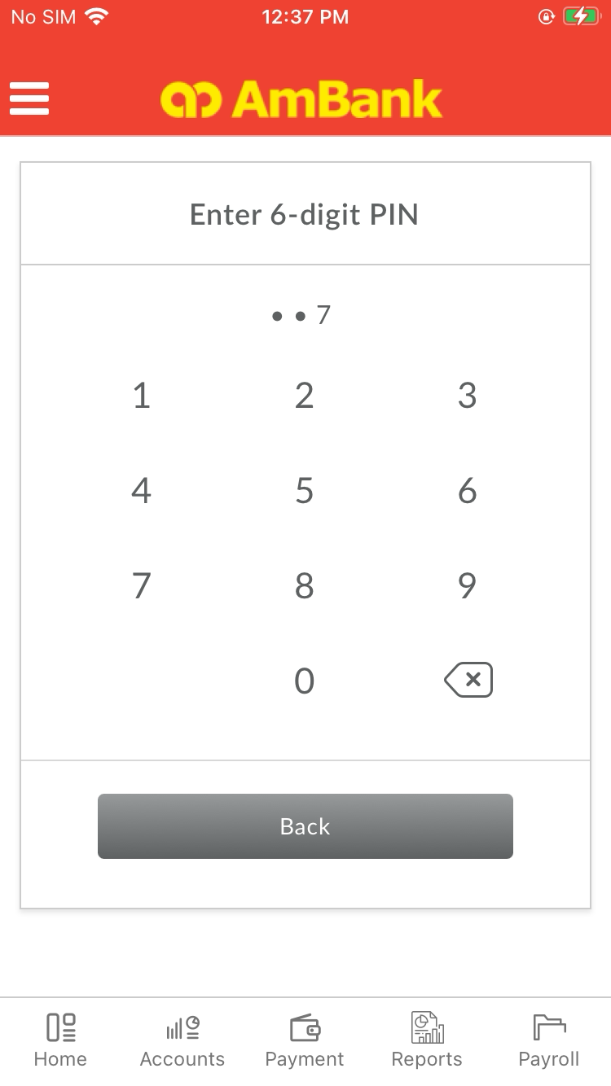  
  
**Test Step 74(PASS) :** [Digital Token] Click [PIN]  
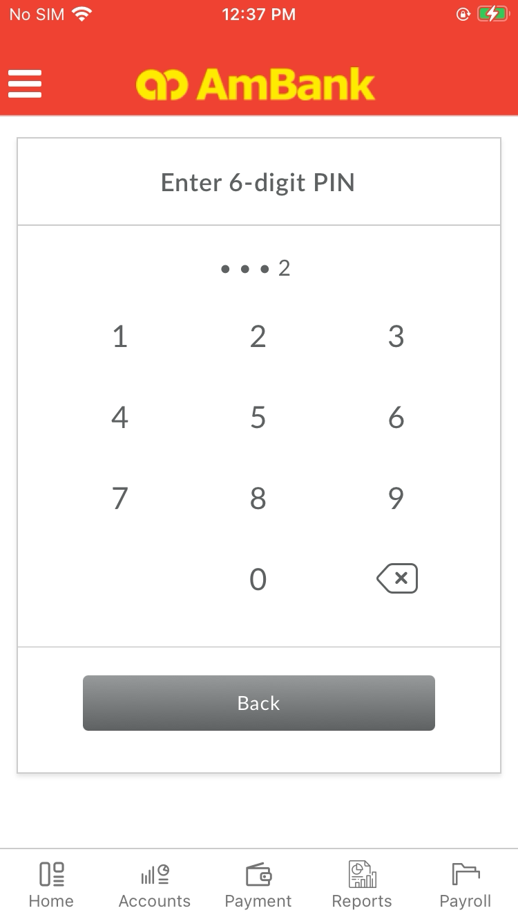  
  
**Test Step 75(PASS) :** [Digital Token] Click [PIN]  
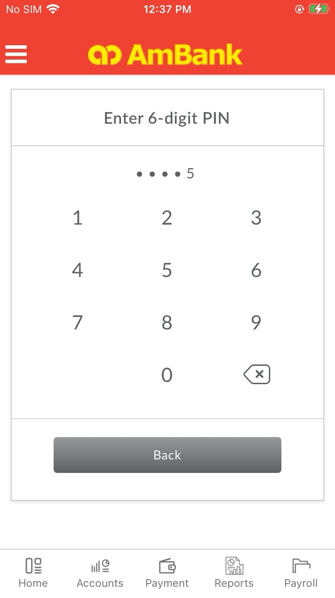  
  
**Test Step 76(PASS) :** [Digital Token] Verify [Status]  
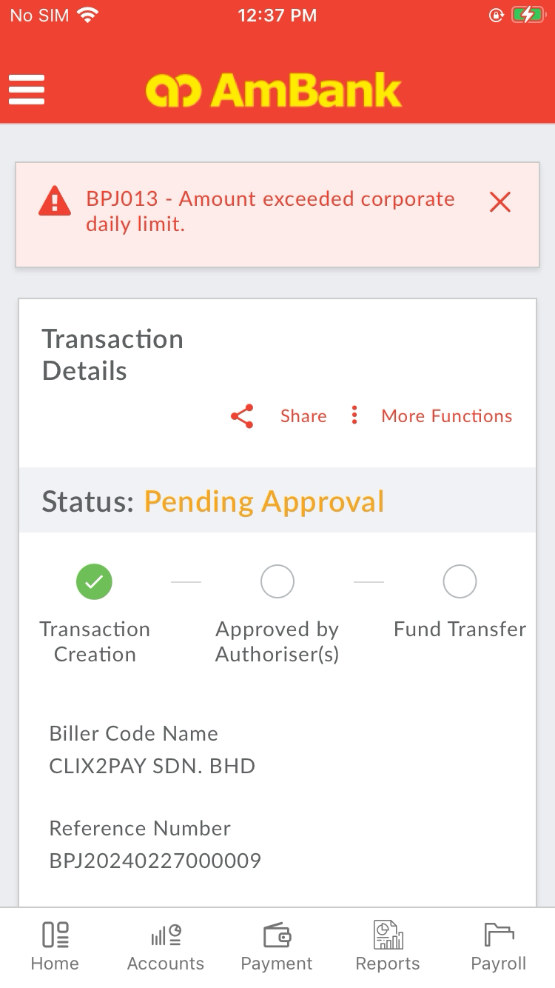  
  
**Test Step 77(PASS) :** [CFO] Click [Menu]  
  
  
**Test Step 78(PASS) :** Swipe Up To LogOut  
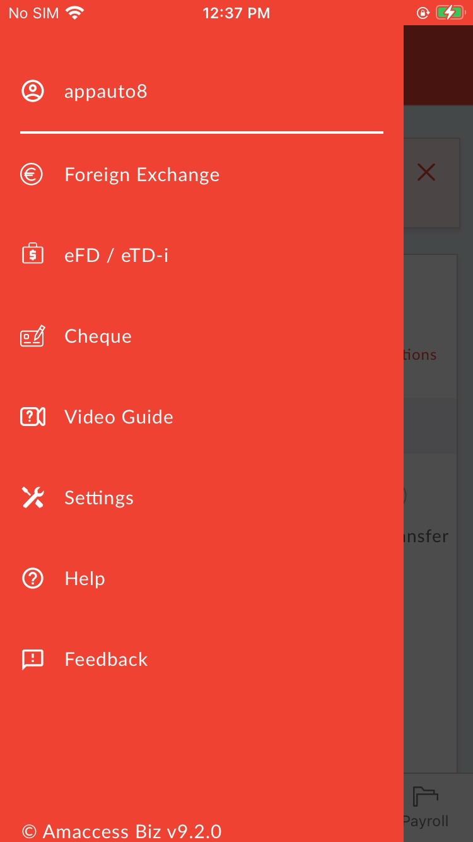  
  
**Test Step 79(PASS) :** [CFO] Click [Logout]  
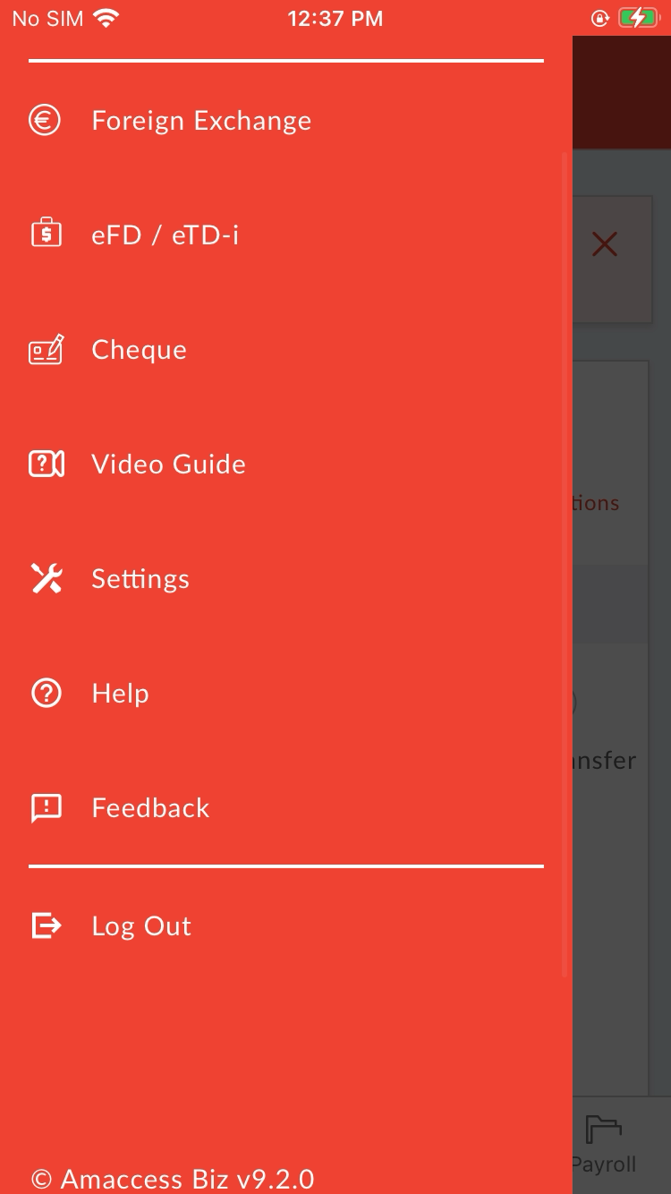  
  
**Test Step 80(PASS) :** [OWA] Input [Username]  
  
  
**Test Step 81(PASS) :** [OWA] Input [Password]  
  
  
**Test Step 82(PASS) :** [OWA] Click [Sign In]  
  
  
**Test Step 83(PASS) :** [OWA] Click [Search Box]  
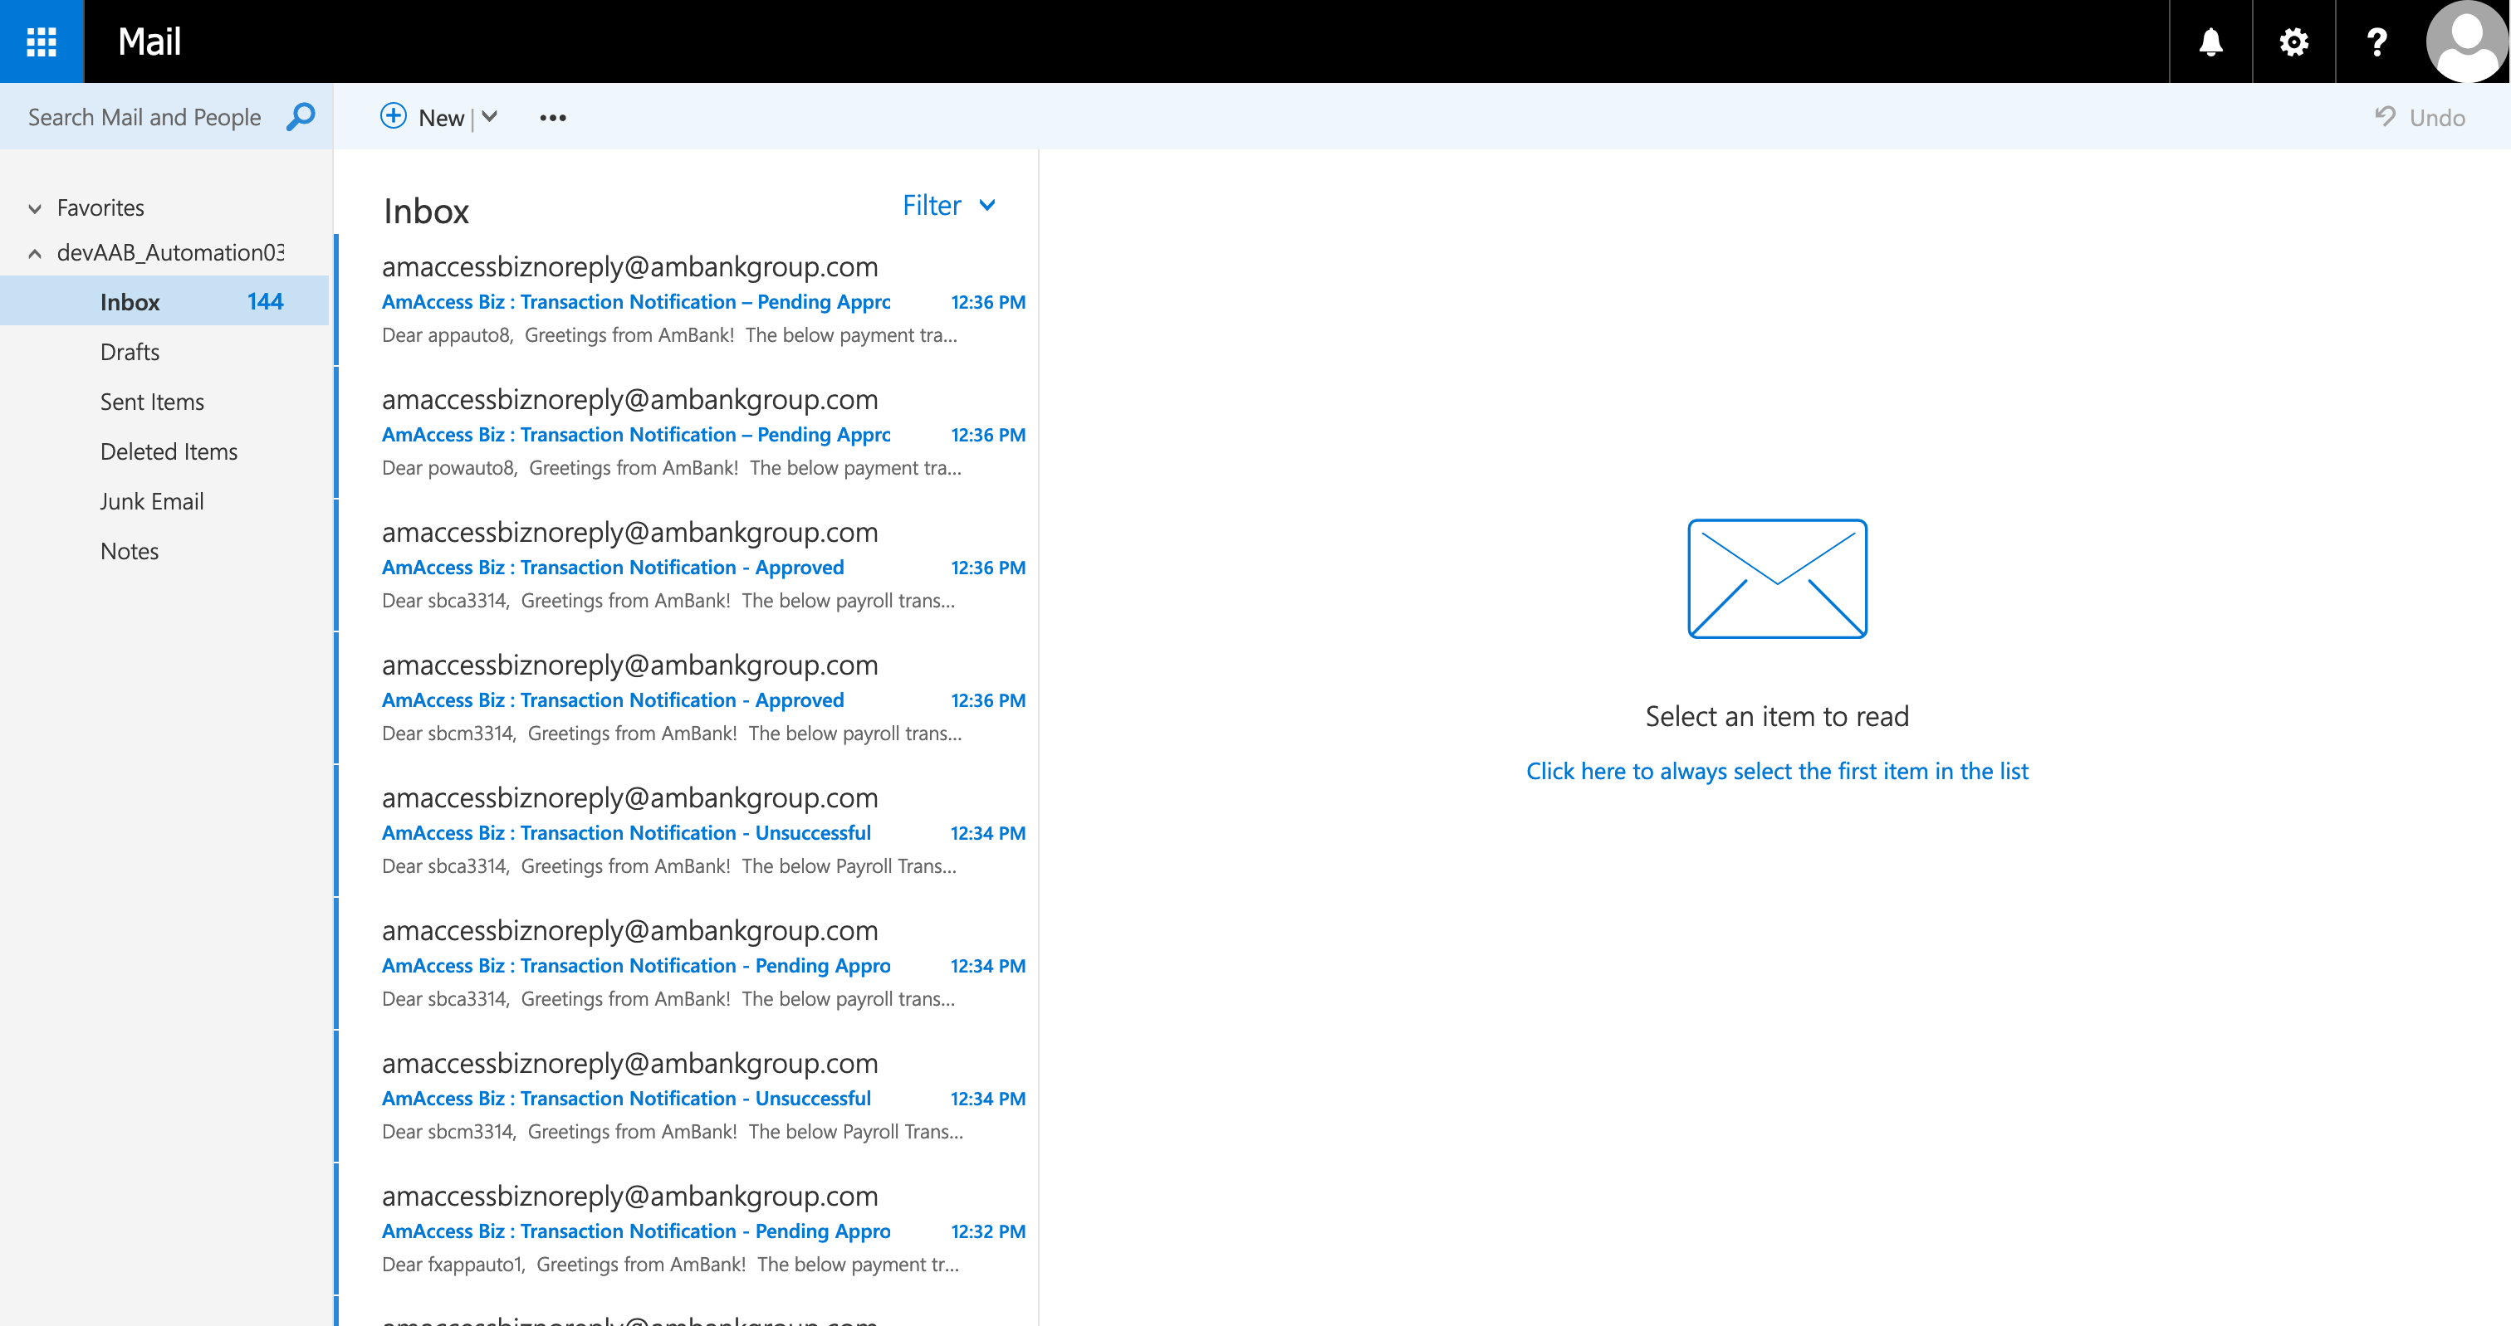  
  
**Test Step 84(PASS) :** [OWA] Clear [Search Box]  
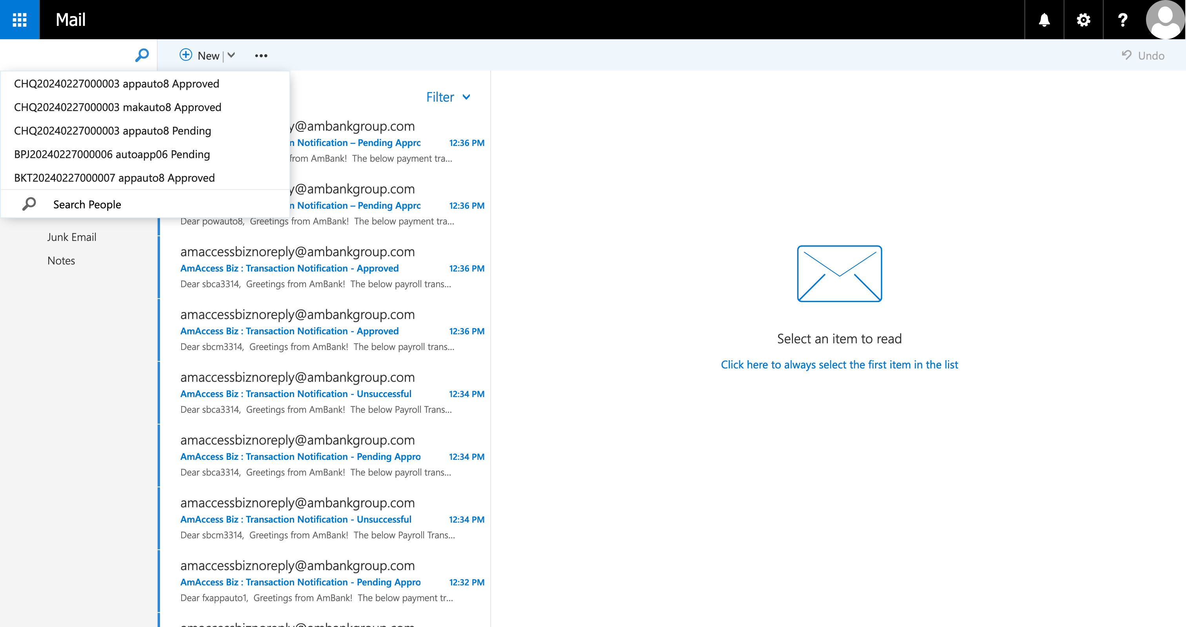  
  
**Test Step 85(PASS) :** [OWA] Set [Search Criteria]  
  
  
**Test Step 86(PASS) :** [OWA] Click [Search]  
  
  
**Test Step 87(PASS) :** [OWA] Click [Email]  
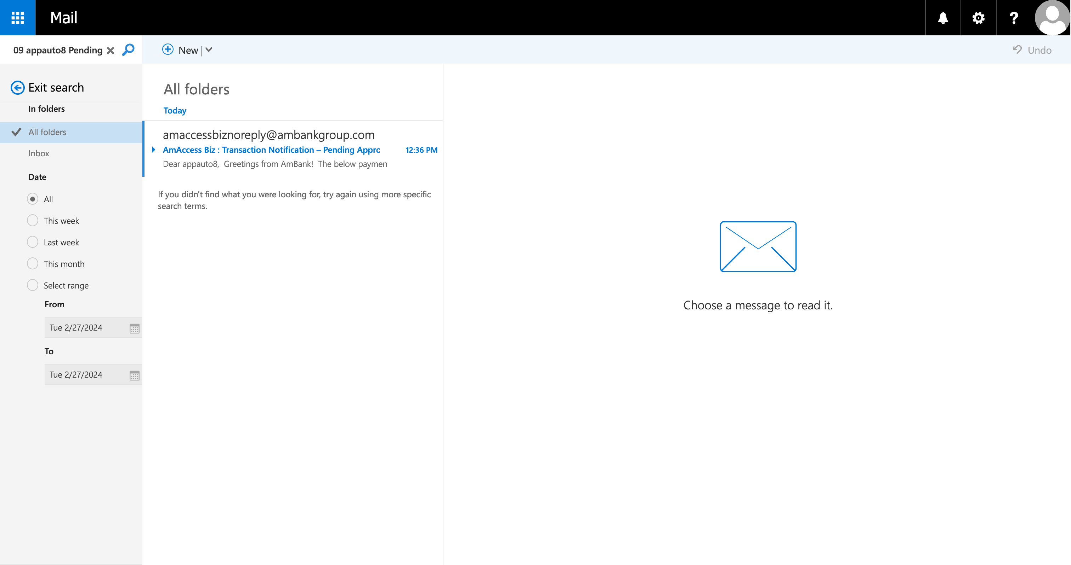  
  
**Test Step 88(PASS) :** [Email] Verify [UserName]   
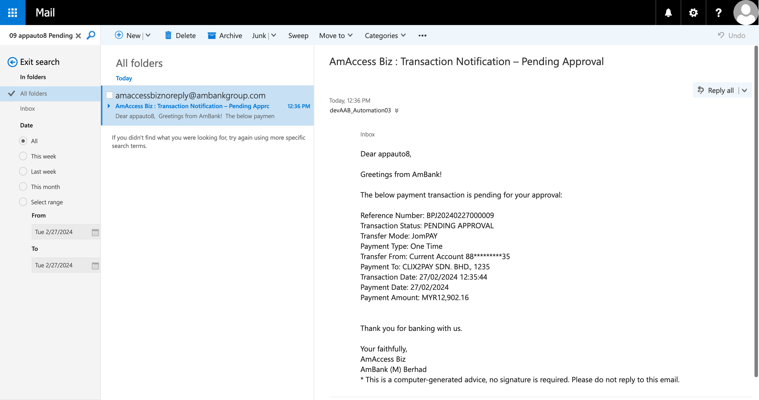  
  
**Test Step 89(PASS) :** [Email] Verify [Reference Number]  
  
  
**Test Step 90(PASS) :** [Email] Verify [Status]  
  
  
**Test Step 91(PASS) :** [OWA] Click [Exit Search]  
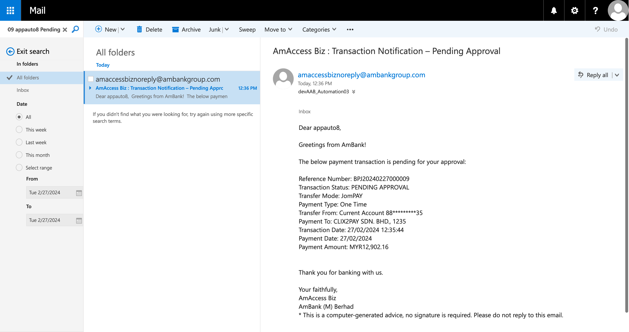  
  
**Test Step 92(PASS) :** [OWA] Click [Search Box]  
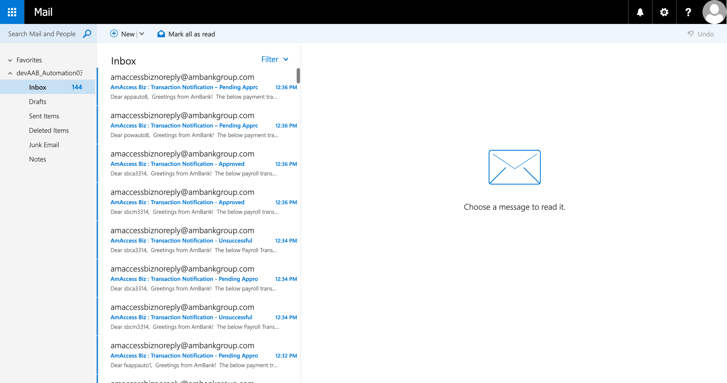  
  
**Test Step 93(PASS) :** [OWA] Clear [Search Box]  
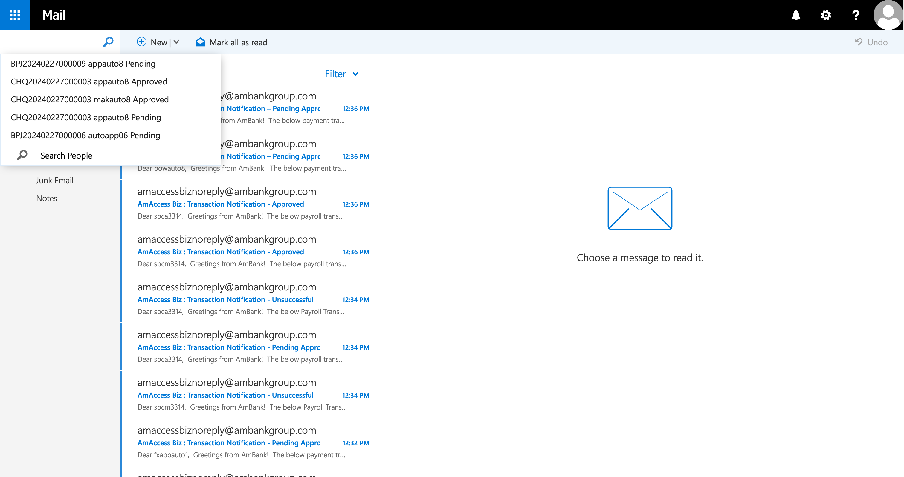  
  
**Test Step 94(PASS) :** [OWA] Set [Search Criteria]  
  
  
**Test Step 95(PASS) :** [OWA] Click [Search]  
  
  
**Test Step 96(PASS) :** [OWA] Click [Email]  
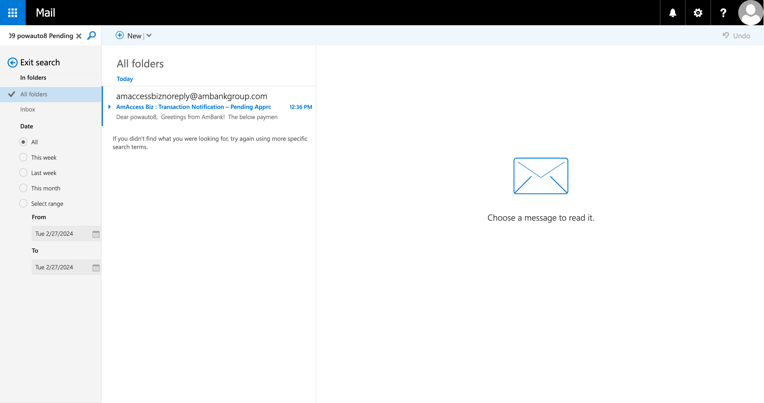  
  
**Test Step 97(PASS) :** [Email] Verify [UserName]   
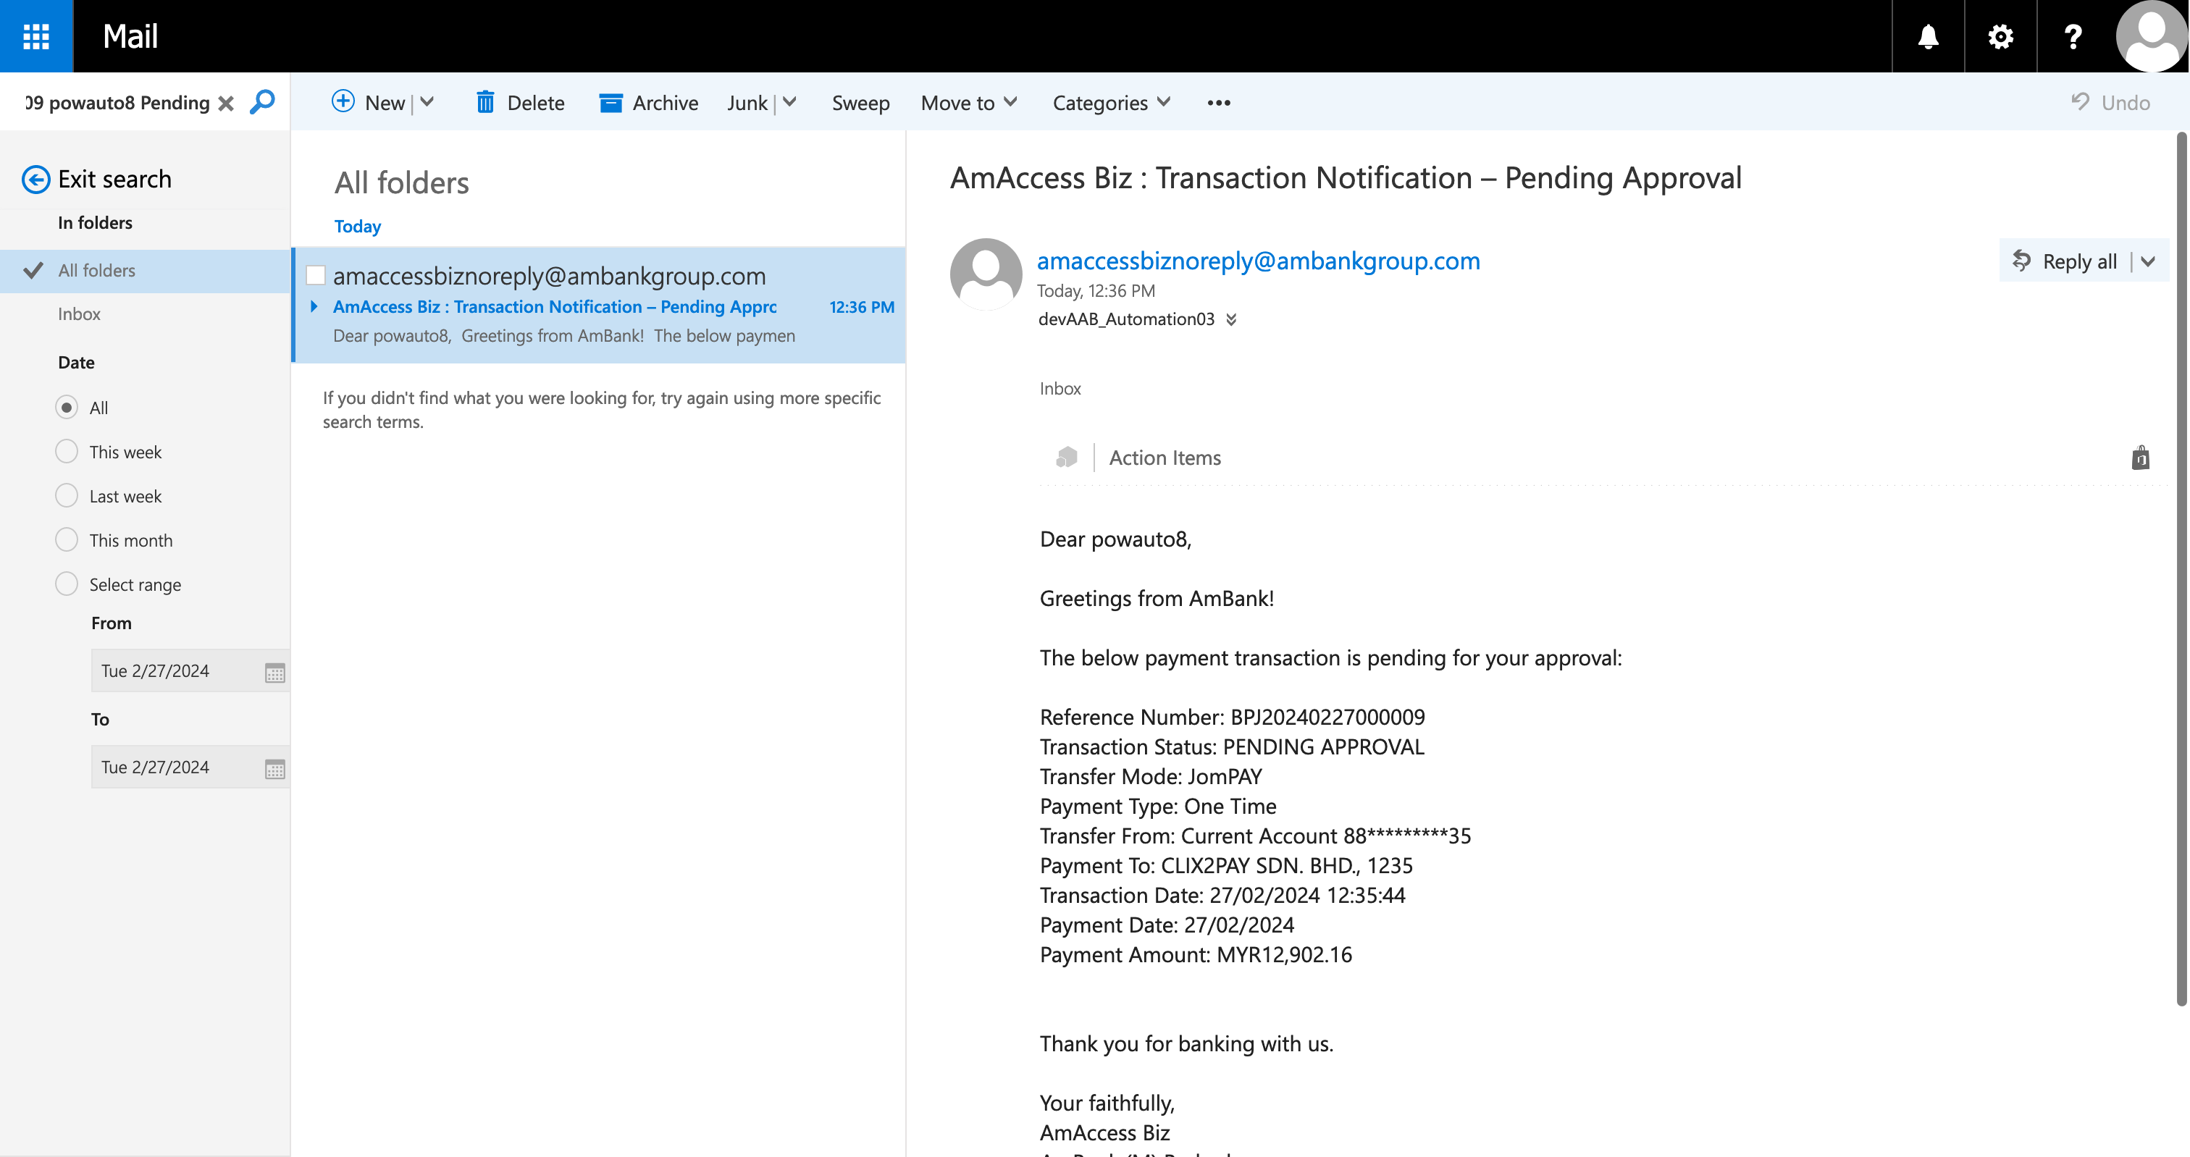  
  
**Test Step 98(PASS) :** [Email] Verify [Reference Number]  
  
  
**Test Step 99(PASS) :** [Email] Verify [Status]  
  
  
**Test Step 100(PASS) :** [OWA] Click [Exit Search]  
  
  
**Test Step 101(PASS) :** [OWA] Click [Icon]  
  
  
**Test Step 102(PASS) :** [OWA] Click [Logout]  
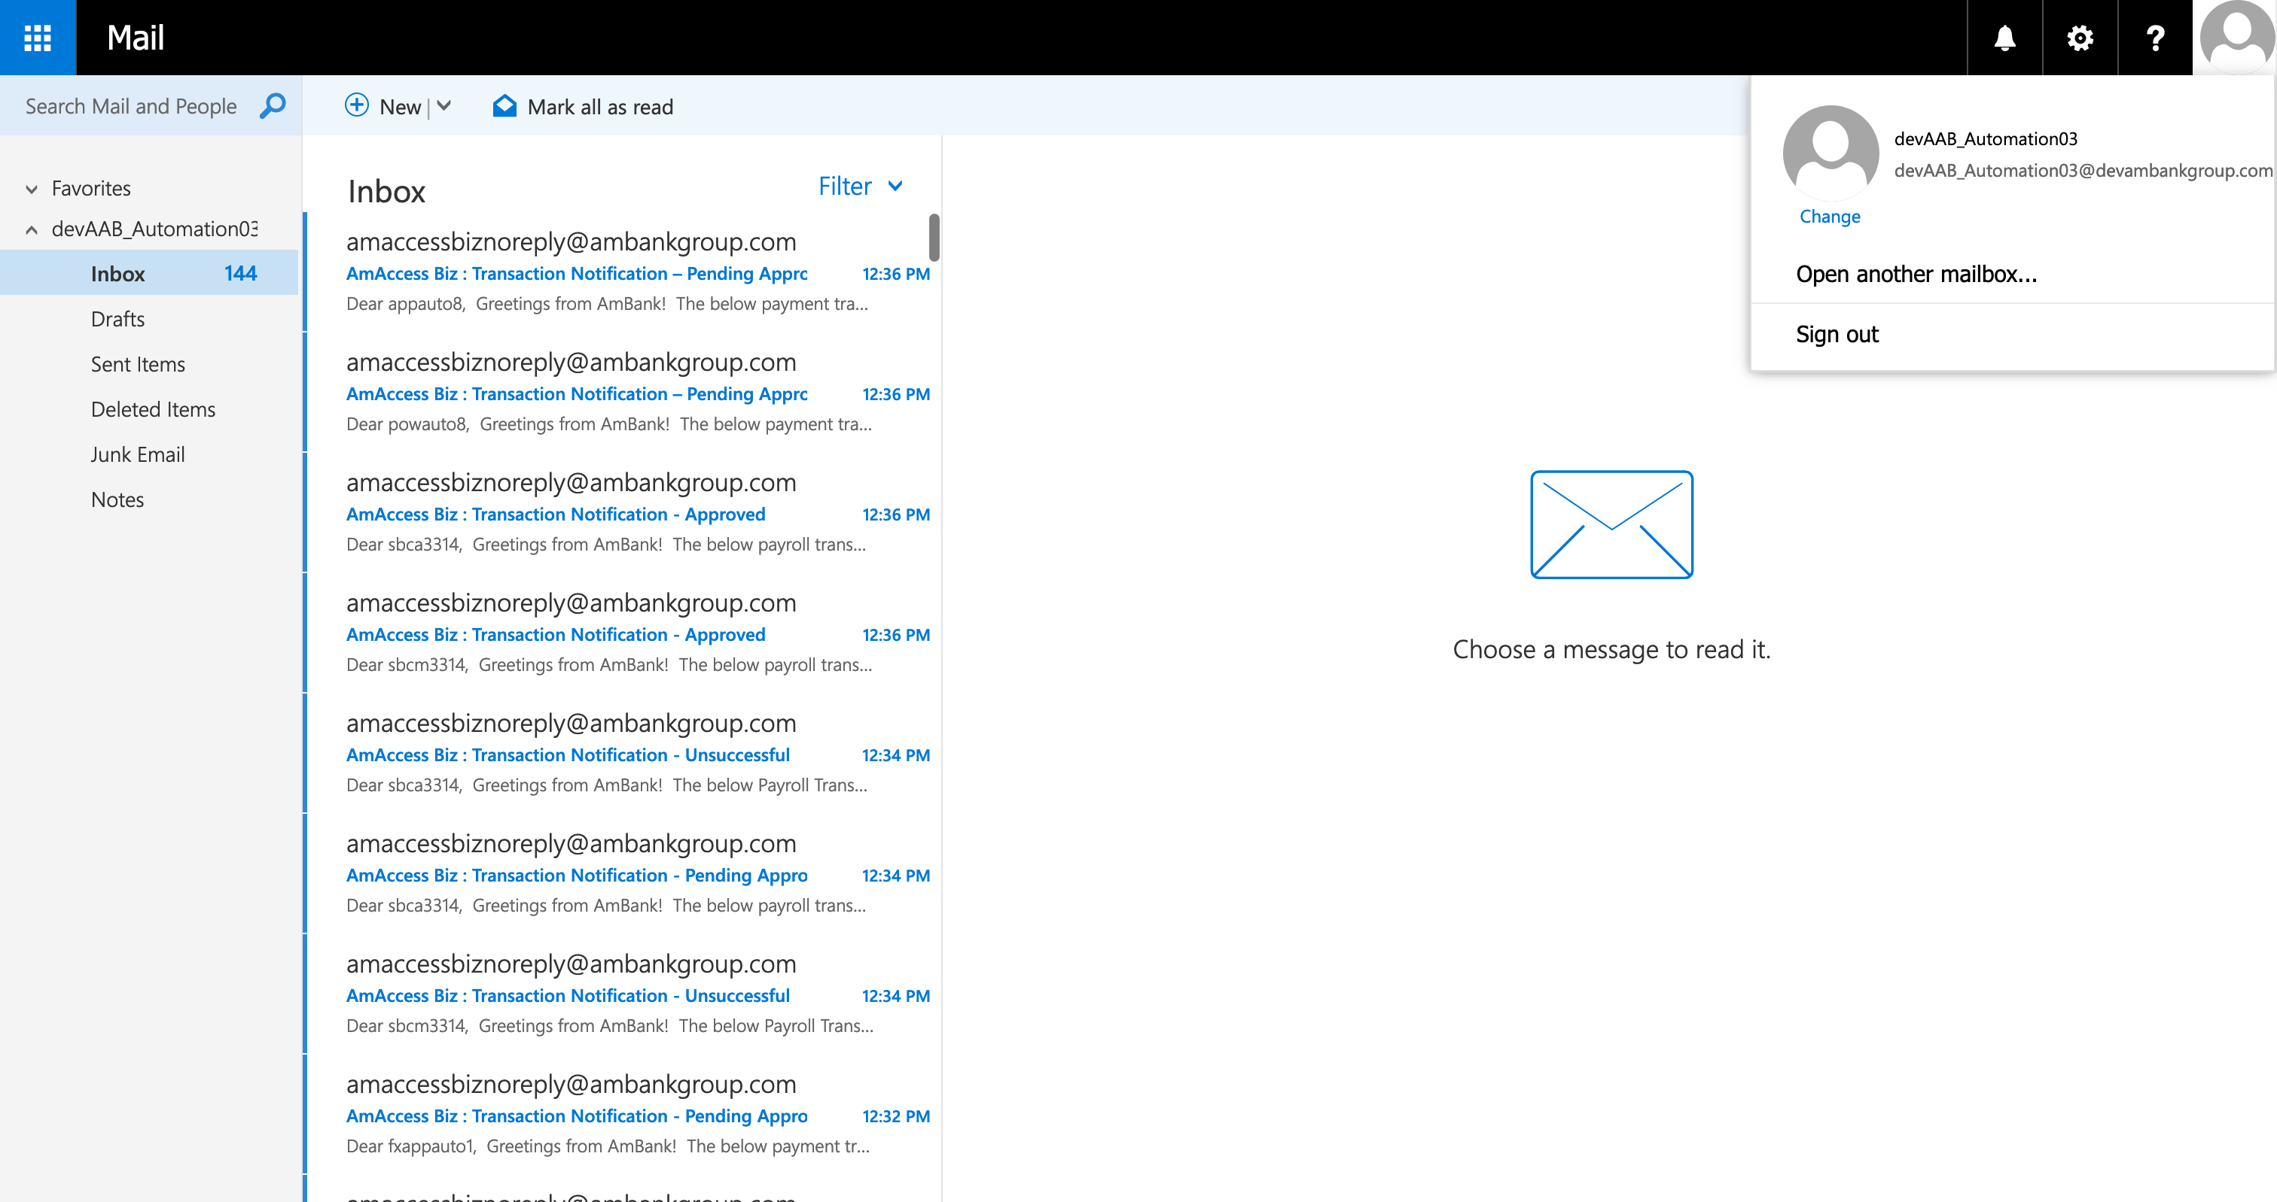  
  
**---------------------------------------- The End ----------------------------------------**